SMART SYSTEM FOR WORKPLACE POSTURE MONITORING USING DEEP LEARNING-BASED CONVOLUTIONAL NEURAL NETWORKS (CNNs).
A PROJECT REPORT

Submitted by

ANKIT SINGH [RA2011003010410]
ARNAV SRIVASTAVA [RA2011003010415]

Under the Guidance of

Dr. M. KARTHIKEYAN

Assistant Professor, Department of Computing Technologies

in partial fulfillment of the requirements for the degree of

BACHELOR OF TECHNOLOGY
in
COMPUTER SCIENCE AND ENGINEERING



DEPARTMENT OF COMPUTING TECHNOLOGIES COLLEGE OF ENGINEERING AND TECHNOLOGY SRM INSTITUTE OF SCIENCE ANDTECHNOLOGY
KATTANKULATHUR- 603 203
MAY 2024



SRM INSTITUTE OF SCIENCE AND TECHNOLOGY KATTANKULATHUR – 603 203
BONAFIDE CERTIFICATE

Certified that 18CSP109L project report titled “SMART SYSTEM FOR WORKPLACE POSTURE MONITORING USING DEEP LEARNING-BASED CONVOLUTIONAL NEURAL NETWORK (CNN)” is the bonafide work of ANKIT SINGH [RA2011003010410] AND ARNAV SRIVASTAVA [RA2011003010415] who carried out the project work under my supervision. Certified further, that to the best of my knowledge the work reported herein does not form any other project report or dissertation on the basis of which a degree or award was conferred on an earlier occasion on this or any other candidate.

Dr. M. KARTHIKEYAN DR. B. ARTHI

SUPERVISOR Associate Professor
Assistant Professor Pannel Head
Department of Computing Technologies Department of computing Technologies

DR. M. PUSHPALATA
HEAD OF THE DEPARTMENT
Department of Computing Technologies

INTERNAL EXAMINER EXTERNAL EXAMINER

ii

Department of Computing Technologies

SRM Institute of Science & Technology

Own Work* Declaration Form
Degree/ Course : B.Tech in Computer Science and Engineering
Student Name : Ankit Singh, Arnav Srivastava
Registration Number : RA2011003010410, RA2011003010415

Title of Work : Smart System for Workplace Posture Monitoring using deep learning- based convolutional neural networks (CNNs).

I / We hereby certify that this assessment compiles with the University’s Rules and Regulations relating to Academic misconduct and plagiarism**, as listed in the University Website, Regulations, and the Education Committee guidelines.

I / We confirm that all the work contained in this assessment is my / our own except where indicated, and that I / We have met the following conditions:

- Clearly referenced / listed all sources as appropriate
- Referenced and put in inverted commas all quoted text (from books, web, etc)
- Given the sources of all pictures, data etc. that are not my own
- Not made any use of the report(s) or essay(s) of any other student(s) either past or present
- Acknowledged in appropriate places any help that I have received from others (e.g. fellow students, technicians, statisticians, external sources)
- Compiled with any other plagiarism criteria specified in the Course handbook / University website
I understand that any false claim for this work will be penalized in accordance with the University policies and regulations.

DECLARATION:
I am aware of and understand the University’s policy on Academic misconduct and plagiarism and I certify that this assessment is my / our own work, except where indicated by referring, and that I have followed the good academic practices noted above.
Student 1 Signature:

Student 2 Signature:

Date:
If you are working in a group, please write your registration numbers and sign with the date for every student in your group.

iii

ACKNOWLEDGEMENT

We express our humble gratitude to Dr. C. Muthamizhchelvan, Vice-Chancellor, SRM Institute of Science and Technology, for the facilities extended for the project work and his continued support.

We extend our sincere thanks to Dr. T. V. Gopal , Dean-CET, SRM Institute of Science and Technology, for his invaluable support.

We wish to thank Dr. Revathi Venkataraman, Professor and Chairperson, School of Computing, SRM Institute of Science and Technology, for her support throughout the project work.

We are incredibly grateful to our Head of the Department, Dr. M. Pushpalatha, Professor, Department of Computing Technologies, SRM Institute of Science and Technology, for her suggestions and encouragement at all the stages of the project work.
We want to convey our thanks to our Project Coordinators, Dr. S. Godfrey Winster, Associate Professor, Dr. M. Baskar, Associate Professor, Dr. P. Murali, Associate Professor, Dr. J. Selvin Paul Peter, Associate Professor, Dr. C. Pretty Diana Cyril, Assistant Professor and Dr. G. Padmapriya, Assistant Professor, Panel Head, Dr. Arthi B, Associate Professor and Panel Members, Dr. Briskilal .J, Assistant Professor, Dr.M.Aruna, Assistant Professor, Dr M. Karthikeyan, Assistant Professor Department of Computing Technologies, SRM Institute of Science and Technology, for their inputs during the project reviews and support.

We register our immeasurable thanks to our Faculty Advisor, Dr. Velmurugan P, Assistant Professor, Department of Computing Technologies, SRM Institute of Science and Technology, for leading and helping us to complete our course.
Our inexpressible respect and thanks to our guide, Dr M. Karthikeyan, Assistant Professor, Department of Computing Technologies, SRM Institute of Science and Technology, for providing us with an opportunity to pursue our project under his / her mentorship.
iv

He provided us with the freedom and support to explore the research topics of our interest. His passion for solving problems and making a difference in the world has always been inspiring.
We sincerely thank all the staff and students of Computing Technologies Department, School of Computing, S.R.M Institute of Science and Technology, for their help during our project. Finally, we would like to thank our parents, family members, and friends for their unconditional love, constant support and encouragement.

ANKIT SINGH [RA2011003010410]

ARNAV SRIVASTAVA [RA2011003010415]

v

ABSTRACT

In the contemporary era marked by the pervasive integration of technology into our daily lives, the "Smart System for Workplace Posture Monitoring" stands out as a pioneering initiative aimed at addressing the growing concerns associated with prolonged computer usage and its impact on posture. The transition from traditional in-person work to telecommuting, driven by global circumstances such as the pandemic, has accentuated the significance of maintaining optimal posture during extended periods of computer-based work. At its core, the smart posture monitoring system integrates cutting-edge sensors and real-time data processing capabilities to provide continuous and detailed insights into an individual's posture during work activities. This technology enables the system to deliver immediate, personalized feedback and recommendations to users, fostering an environment that prioritizes ergonomic considerations and mitigates potential health issues associated with poor posture. The project's significance lies not only in its technical innovation but also in its potential to revolutionize occupational risk prevention. It introduces a proactive approach to posture management, shifting the focus from reactive measures to real-time guidance that empowers individuals to maintain optimal postures throughout their workday. This user-centric solution aligns with the evolving nature of contemporary workspaces, where technology becomes an enabler for holistic well-being.
In summary, the "Smart System for Workplace Posture Monitoring" project addresses a critical aspect of modern work life, offering an advanced and user-friendly tool that not only monitors but actively contributes to the improvement of workplace posture, thereby promoting long-term health and productivity in the digital age.

vi

TABLE OF CONTENT

TITLE PAGE NO.

ABSTRACT vi
LIST OF TABLES vii
LIST OF FIGURES ix
LIST OF SYMBOLS, ABBREVIATION x

- INTRODUCTION 1
1.1 General 2
1.2 Objective 3
1.3 Motivation 4

- LITERATURE REVIEW 6
2.1 Literature Reviews 7
2.2 Challenges and Limitation 11
2.3 Objective 13

- PROBLEM STATEMENT 17
3.1 Problem Statement 18

- RESEARCH METHODOLOGY 19
4.1 Research Methodology 19

- INNOVATION 20
5.1 Innovation 20
5.2 Introduction to Computer Vision 22
5.3 Scope and Application 32

- ARCHITECTURE 35
6.1 Architecture 35
6.2 Architecture Diagram 37
6.3 Proposed Modules 37

vii
- TRAINING AND VALIDATION 40
7.1 Training and Validation 40
7.2 Algorithm Description 42
7.3 UML Diagrams 45

- CODE IMPLEMENTATION 47
8.1 model.py 47
8.2 image.py 53
8.3 realtime.py 61

- CONCLUSION 70
9.1 Future Enhancement 73
9.2 Conclusion 76

- REFERENCES 78

- APPENDIX 82

- PLAGARISM REPORT 83

- PUBLICATION PROOF 84

viii

LIST OF FIGURES

Figure 1 - Research Methodology 16
Figure 2 - Flow of Posture Detection 20
Figure 3 - Key Points in the Human Body 21
Figure 4 - Architecture Diagram 29
Figure 5 - Straight Posture 32
Figure 6 - Rest Posture 33
Figure 7 - UML Diagram 36
Figure 8 - Sequence Diagram 37
Figure 9 - Straight sitting Posture of Single Person 69
Figure 10 - Straight Sitting Posture of Multiple Peoples 69
Figure 11- Output Image 70
Figure 12 -Folding legs posture …………………………………………...70
Figure 13. Output Image……………………………………………………72
Figure 14. Folding hands and rest sitting posture…………………………..72

ix

LIST OF ABBREVIATIONS

Abbreviation | Words
CV | Computer Vision
CV2 | Open Computer Vision
LBP | Local Binary Patterns
AI | Artificial Intelligence
ML | Machine Learning
DL | Deep Learning
CNN | Convolution Neural Network
ANN | Artificial Neural Network

x

CHAPTER- 1

INTRODUCTION

The widespread prevalence of lower back pain emerges as a significant and pervasive health concern, affecting a considerable proportion of the global population. The annual incidence of this condition varies notably, encompassing a range from 15% to 45%. This widespread affliction is particularly pronounced among adults, as articulated by the World Health Organization. Adult individuals bear a more substantial burden of lower back pain compared to their younger counterparts, and this prevalence is exacerbated by the condition's status as a prominent catalyst for work-related absences and disruptions in everyday activities.

The implications of lower back pain extend far beyond mere discomfort, as it significantly influences the ability of individuals to engage in their professional responsibilities and carry out routine daily tasks. The World Health Organization's acknowledgment of the prominence of this condition underscores the imperative to address and mitigate its impact on individual health and overall well-being. Understanding the prevalence and disproportionate occurrence of lower back pain in the adult population illuminates the urgent need for comprehensive measures aimed at prevention, management, and improved workplace ergonomics to alleviate the burdens associated with this widespread health issue.

Recognizing the far-reaching impact of lower back pain on individuals across the globe, the imperative to prioritize the creation of a system that not only addresses this issue but also promotes an ergonomic work environment becomes increasingly evident. The significance of ergonomics in this context cannot be overstated, as empirical research consistently highlights its myriad benefits, ranging from tangible enhancements in productivity to the more intangible yet crucial improvement in mental health.

The multifaceted influence of lower back pain extends beyond mere physical discomfort, affecting individuals in their daily lives and professional endeavors. This acknowledgment underscores the critical need for an integrated and efficient system designed to mitigate the challenges posed by lower back pain and concurrently foster workspaces that prioritize ergonomic principles. Ergonomics, as a discipline, plays a pivotal role in creating environments that support optimal physical health and psychological well-being, aligning seamlessly with the broader goal of cultivating workspaces conducive to sustained individual and collective success.

The advent of the COVID-19 pandemic has underscored the critical need to address the issue of lower back pain, particularly in light of the widespread adoption of mobile and laptop screens during this unprecedented period. The increased reliance on these devices has led to extended periods of individuals maintaining incorrect postures, which, in turn, raises the possibility of adverse effects on their musculoskeletal health. Consequently, the significance of maintaining a proper seating posture has risen to the forefront as a crucial preventive measure against the potential long-term consequences attributed to the heightened and sustained use of screens. Recognizing the implications of this behavioral shift, it becomes imperative to prioritize interventions that not only alleviate immediate discomfort but also safeguard against the potential development of chronic musculoskeletal issues associated with prolonged incorrect postures during extended screen usage.

In the epoch of the Internet of Things (IoT), a transformative wave that has reshaped numerous industries, this paper presents a cutting-edge sensor-based application as a forward-looking response to the challenges posed by lower back pain. By capitalizing on the expansive capabilities of IoT, wearable devices, and automated systems, this application aspires not only to address lower back pain but also to elevate overall physical well-being. What distinguishes this system from its predecessors, which predominantly focus on posture detection, is its holistic approach. Going beyond mere detection, the proposed system integrates a sophisticated notification system that provides real-time feedback to users. Additionally, it introduces a novel feature: the ability to meticulously track the historical evolution of sitting postures. This multifaceted approach positions the proposed system as a pioneering solution, offering a comprehensive and nuanced response to the complex challenges associated with lower back pain and musculoskeletal health.

A defining trait of the proposed system is its unique dual functionality, setting it apart from conventional approaches. It not only excels in the precise identification of improper postures but also integrates an extensive notification system designed for swift and effective corrective actions. Going beyond immediate interventions, the system further distinguishes itself by systematically recording and analyzing the historical patterns of sitting postures. This holistic approach expands the scope of addressing lower back pain, providing a nuanced understanding of users' postural habits over time. By combining immediate corrective measures with a long-term posture analysis, the proposed system offers a comprehensive and adaptive solution to the multifaceted challenges associated with lower back pain.

To ensure that the proposed system aligns with the needs and concerns of users, an open-ended general survey is conducted to gauge public grievances related to lower back pain. The insights garnered from the survey are systematically incorporated into the design of a prototype, underscoring the user-centric approach adopted in the development of the system. This survey-driven prototype design ensures that the final system resonates with users, effectively addressing their specific challenges and requirements related to lower back pain.

In the pursuit of ensuring that the proposed system is finely attuned to the diverse needs and concerns of users, a comprehensive general survey is conducted. This survey is meticulously designed to delve into the public's grievances regarding lower back pain, gathering valuable insights that serve as a foundation for the subsequent phases of system development. The findings derived from this survey are not merely acknowledged but are actively and systematically incorporated into the intricate design of a prototype. This approach underscores the system's commitment to a user-centric paradigm, where the incorporation of user feedback plays a pivotal role. The survey-driven prototype design is not just a procedural step; it becomes a strategic imperative that guarantees the final system resonates authentically with users, effectively addressing their specific challenges and requirements pertaining to lower back pain. This iterative and inclusive approach ensures that the system evolves in tandem with user needs, fostering a dynamic and responsive solution to the complex issues associated with lower back pain.

1.3. MOTIVATION

This research centers on prioritizing the health and welfare of telecommuting workers, especially those engaged in extended computer use. The inherent acknowledgment of potential health complications arising from suboptimal posture underscores the immediate necessity for precautionary actions. Addressing the complications introduced by the abrupt shift to home workstations is crucial, particularly due to the potential absence of ergonomic standards for comfortable positioning. The study places considerable importance on addressing ergonomic concerns to improve the overall work experience for individuals engaged in telecommuting. Recognizing the challenges inherent in transitioning to home-based work environments, the study emphasizes the need to proactively manage health-related issues stemming from extended computer usage and less-than-ideal ergonomic conditions.

Furthermore, this research situates itself at the intersection of occupational risk prevention within the medical sector, placing a strong emphasis on the crucial task of identifying and mitigating health risks that are specifically tied to the practice of telecommuting. The study underscores the pivotal role played by an automated tool meticulously crafted to quantify the degrees of incorrect posture prevalent among teleworkers, thereby significantly amplifying the effectiveness of risk management practices in the occupational health domain. In the broader context of occupational health, this research magnifies the significance of a technologically advanced solution adept at precisely assessing and proactively addressing the potential health hazards intricately linked to the evolving landscape of telecommuting.

Presented as a pioneering resolution to the recognized challenges, the research introduces a specialized system crafted explicitly for the detection and analysis of telecommuting employees' postures. The study underscores the integration of state-of-the-art technology, notably convolutional neural networks, and specialized hardware in the system's development. This advanced technological framework facilitates real-time video processing, underscoring the system's proficiency in accurately identifying postures of the neck, shoulders, and arms. The utilization of cutting-edge components amplifies the system's capabilities, positioning it as an innovative and efficient solution to the complexities associated with posture analysis in the realm of telecommuting.

A distinctive feature of the suggested system is its capacity to provide prompt guidance to telecommuters, contributing to the prevention of potential health issues linked to incorrect posture. The effectiveness of the system is emphasized by its aptitude for real-time video processing, accomplishing speeds of up to 25 frames per second. Simultaneously, the system maintains minimal power consumption, operating below 10 watts through dedicated hardware—ensuring a balance between sustainability and practicality. This dual capability not only reinforces the system's efficiency in delivering timely recommendations but also highlights its commitment to environmental sustainability through optimized power consumption.

The study's credibility is fortified by emphasizing the thorough implementation and rigorous testing undergone by the system, guaranteeing the generation of dependable results. The favorable results achieved by the study, showcasing an accuracy rate surpassing 80% in terms of posture detection, serve as a testament to the effectiveness and reliability of the proposed system. This robust validation process not only bolsters the study's trustworthiness but also solidifies the confidence in the system's ability to accurately detect and analyze telecommuters' postures, marking a significant stride in the advancement of workplace health technology.

In summary, the proposed system is envisioned to serve as a transformative force, fostering healthier work habits among telecommuting employees and leaving a lasting impact on occupational health practices. Going beyond its immediate applications, the study represents a substantial contribution to the broader field of occupational health by presenting an innovative solution that adeptly addresses the evolving challenges brought about by the paradigm shift towards telecommuting. The foresight embedded in the proposed system not only addresses current issues but also lays the groundwork for a more resilient and health-conscious approach to the dynamic landscape of modern work environments.

CHAPTER- 3

LITERATURE REVIEW

The comprehensive literature review for the project titled "Smart System for Workplace Posture Monitoring" delves into a rich tapestry of existing research and developments that shape the landscape of workplace posture monitoring. Prolonged incorrect posture has been a focal point in numerous studies, particularly within sedentary work environments, where the implications on individuals' health and well-being are considerable. The literature underscores the prevalent issue of musculoskeletal disorders associated with poor posture and underscores the critical need for sophisticated posture monitoring tools to alleviate health risks.

A notable trend in recent advancements is the integration of cameras as a pivotal sensing modality in smart systems designed for posture monitoring. This approach holds promise, providing a non-intrusive and potentially more accurate means of posture detection compared to traditional methods. The marriage of computer vision and machine learning techniques, especially the utilization of convolutional neural networks (CNNs), has been a focal point of exploration. These technologies facilitate the real-time processing of video data, enabling the identification of key postural elements, including the neck, shoulders, and arms. The literature collectively paints a picture of evolving methodologies, showcasing the capacity of camera-based systems to deliver nuanced and detailed analyses of individual postures.

Numerous research endeavors have put forth innovative solutions that harness the capabilities of specialized hardware, emphasizing the significance of efficient real-time video processing with minimal power consumption. These endeavors have yielded encouraging results, showcasing systems that achieve remarkable accuracy rates in the detection of postural nuances. This success not only validates the efficacy of such systems but also positions them as compelling contenders for integration into occupational health applications.

The integration of specialized hardware, coupled with real-time video processing capabilities, ensures that posture monitoring systems can operate seamlessly within the dynamic contexts of various occupational settings. By minimizing power consumption, these systems align with sustainability goals while maintaining a high level of accuracy in posture detection. This confluence of technological prowess and practicality positions such systems as valuable tools in the realm of occupational health, where the prevention of health issues holds paramount importance.

Furthermore, the literature underscores the broader implications of these dual-functional systems in transforming the landscape of workplace ergonomics. Providing not just detection but also actionable insights and recommendations addresses the multifaceted nature of health challenges associated with sedentary work environments. This comprehensive approach resonates with the evolving needs of modern workplaces, where employee well-being is increasingly prioritized.

- The methodology for "Human Body Pose Estimation and Applications" begins with the collection and preprocessing of a diverse dataset, encompassing various human poses. Data augmentation techniques are applied to enhance model robustness.. The training procedure involves an optimizer, learning rate, and careful consideration of preventing overfitting. Evaluation metrics, such as accuracy and precision, are employed to assess model performance. Experimental setup includes hardware specifications and software tools. Results are presented through quantitative metrics and visualizations, with an analysis of the model's efficacy. The paper explores applications in computer vision, robotics, and healthcare, highlighting the proposed model's potential impact.

Pros:
Colour-Based Input
Red-Green-Blue (RGB) images are the type of images seen in daily life. The images captured by standard cameras are in this mode, and hence this is the most commonly seen image for pose estimation. Most of the models developed for pose estimation can directly take in the RGB image.

Static and Dynamic Input
Static images are still images captured using a camera. Here, the body pose of the individual is fixed with respect to time; hence the estimation is comparatively simple.
Cons:

Limited Generalizability: The proposed methodology may have limitations in terms of generalizability to diverse populations or scenarios, potentially impacting the model's effectiveness in certain real-world applications.

Overemphasis on a Specific Model: If the paper overly emphasizes a specific pose estimation model without thoroughly exploring alternative architectures, it may limit the depth of the research and miss opportunities for comparison and validation.

- Graphically estimating a person's pose is a computer vision task called human pose estimation. Predicting the location of a person's body parts or joints is an everyday use case for this method. The vast number of potential uses for this kind of technology has made it one of the most intriguing areas of study in computer vision. To estimate a human's 3D stance from 2D photos, the location of the important body joints in 3D space shall be determined. Despite extensive research in the field of computer vision, this issue continues to pose significant difficulties. This is because the depth information is lost when obtaining 2D images of 3D objects, leading to ambiguity. While using a 2D Image as input, only a portion of a person's body is exhibited; estimating their 3D position is challenging. In this study, we offer methods for recovering a human's 3D position from a 2D photograph when just a portion of the body is visible.

Pros:

Point-Based Pose Estimator (PBPE):
We offer a new approach to solving 3D Pose Estimation in world coordinates, one that takes a point cloud as input and uses deep learning to extract a set of 3D points that represent the skeleton of a human from the cloud.

PointNet Architecture:
PointNet is a ground-breaking piece of research because it can decode a 3D space into a network of points. This model accepts a predetermined number of random point clouds and achieves impressive accuracy and efficiency in tasks like object recognition.

Cons:

Insufficient Consideration of Ethical Implications: The paper may not adequately address ethical considerations related to privacy, bias, or potential misuse of pose estimation technology, which is crucial given the sensitivity of human body-related data.

Incomplete Future Work Discussion: If the paper lacks a comprehensive discussion of potential future research directions or improvements, it may miss opportunities to guide and inspire further advancements in the field.
- Human pose estimation has tangible benefits in the growing trends in computer vision-based technology. Human-computer interactions can be enhanced by the applications of human pose estimation. This survey will include a set of papers for analysis of performance as well as the occlusion. In this paper, we discuss some of the methods used for human pose estimation to come up with a better method and to know the challenges with each method.

Pros:

Camera Based Estimation
In human pose is not directly analyzed by the 3D estimation, but by introducing an intermediate 2D measurement, as 2D provides us with more accuracy. For the purpose of delineating the 2D measurements to 3D estimation, they have performed simple data driven matching.

Sensor Based Estimation
Human pose estimation can be made efficient with the help of two depth sensors, which is the approach carried out in [5]. The two depth sensors, one captures movement of the front portion of the body, while the other captures the back portion.

Cons:

Insufficient Consideration of Ethical Implications: The paper may not adequately address ethical considerations related to privacy, bias, or potential misuse of pose estimation technology, which is crucial given the sensitivity of human body-related data.

Incomplete Future Work Discussion: If the paper lacks a comprehensive discussion of potential future research directions or improvements, it may miss opportunities to guide and inspire further advancements in the field.
- Graphically estimating a person's pose is a computer vision task called human pose estimation. Predicting the location of a person's body parts or joints is an everyday use case for this method. The vast number of potential uses for this kind of technology has made it one of the most intriguing areas of study in computer vision. To estimate a human's 3D stance from 2D photos, the location of the important body joints in 3D space shall be determined. Despite extensive research in the field of computer vision, this issue continues to pose significant difficulties. This is because the depth information is lost when obtaining 2D images of 3D objects, leading to ambiguity. While using a 2D Image as input, only a portion of a person's body is exhibited; estimating their 3D position is challenging. In this study, we offer methods for recovering a human's 3D position from a 2D photograph when just a portion of the body is visible.

Pros:

Point-Based Pose Estimator (PBPE):
We offer a new approach to solving 3D Pose Estimation in world coordinates, one that takes a point cloud as input and uses represent the skeleton of a human from the cloud.

PointNet Architecture:
PointNet is a ground-breaking piece of research because it can decode a 3D space into a network of points. This model accepts a predetermined number of random point clouds and achieves impressive accuracy and efficiency in tasks like object recognition and semantic segmentation.

Cons:

Insufficient Consideration of Ethical Implications: The paper may not adequately address ethical considerations related to privacy, bias, or potential misuse of pose estimation technology, which is crucial given the sensitivity of human body-related data.

Incomplete Future Work Discussion: If the paper lacks a comprehensive discussion of potential future research directions or improvements, it may miss opportunities to guide and inspire further advancements in the field.

In essence, the literature review not only lays the groundwork for the proposed smart system but also acts as a roadmap for future research endeavors in the field of workplace posture monitoring. It accentuates the need for a balanced perspective that combines theoretical advancements with practical validation, user-centric considerations, and a forward-looking approach to drive innovation and progress in this crucial area of occupational health.

2.2. CHALLENGES AND LIMITATIONS

Effective implementation of a smart system for workplace posture monitoring encounters several challenges and considerations that need careful attention:

2.2.1. Ergonomic Setup Variability:
- The diverse home environments of telecommuters present a notable challenge as setups may vary significantly, impacting the system's ability to adapt to the nuances of different workstations.

2.2.2. Limited Physical Interaction:
- The system lacks physical intervention capabilities, limiting its capacity to actively correct or adjust the user's posture. This absence of real-time adjustments may impede immediate improvements in ergonomic practices.

2.2.3. User Compliance and Engagement:
- Ensuring consistent user engagement and compliance with the system's recommendations is a persistent challenge. Users may disregard or forget to follow suggested postural adjustments, compromising the overall effectiveness of the system.

2.2.4. Privacy Concerns:
- The utilization of real-time video processing raises privacy concerns, involving continuous monitoring of the user's body. The system must be implemented with robust privacy measures to safeguard sensitive information.

2.2.5. System Calibration for Diverse Users:
- Calibration of the system to accommodate diverse body types and postural habits poses a challenge. A one-size-fits-all approach may prove ineffective, necessitating a system capable of adapting to the unique characteristics of different users.

2.2.6. Hardware Accessibility and Cost:
- The reliance on specialized hardware may limit the widespread adoption of the system due to issues related to accessibility and higher implementation costs for both users and organizations.

2.2.7. Technical Expertise Requirement:
- Users may encounter challenges related to technical expertise required for setting up and maintaining the specialized hardware. This may potentially limit the system's usability among individuals with limited technological proficiency.

2.2.8. Potential for False Positives/Negatives:
- Despite an accuracy rate exceeding 80%, the system may still encounter instances of false positives or negatives. Addressing these occurrences is crucial to ensure the reliability of postural detection.

2.2.9. Adaptability to Dynamic Work Environments:
- The system may face challenges in adapting to dynamic work environments where telecommuters frequently change their work locations or switch between different devices. Its adaptability to such changes is essential for continuous monitoring.

2.2.10. Network and Connectivity Issues:
- The reliance on real-time video processing demands stable network connectivity. Any disruptions or latency issues may affect the system's ability to provide timely feedback, impacting its overall effectiveness.

2.2.11. Long-term Health Impact Assessment:
- The study may not cover the long-term health impact of relying on the system. Additional research is needed to assess its effectiveness in preventing health issues over an extended period, ensuring a comprehensive understanding of its implications.

These challenges collectively underscore the complexity of implementing a smart system for workplace posture monitoring and highlight the need for a meticulous approach to overcome these hurdles for the system's successful integration into diverse telecommuting environments.

2.3. OBJECTIVE

This ambitious and comprehensive project is strategically designed to pioneer the development of an innovative Automated Posture Detection System explicitly tailored for the distinctive needs of telecommuting employees immersed in prolonged computer usage. The core objective of this pioneering initiative revolves around automating the intricate process of detecting and analyzing the postures of telecommuters during extended sessions of computer work. Acknowledging the unique ergonomic challenges posed by the transition to home workstations, the project takes a proactive stance by integrating real-time feedback mechanisms that actively advocate for and reinforce comfortable and proper positioning.

At the heart of this endeavor lies a dedicated focus on the creation of cutting-edge tools and algorithms meticulously crafted to quantify the degree of incorrect posture prevalent among telecommuting employees. This precision in quantification plays a pivotal role in not only pinpointing but also proactively addressing potential health issues stemming from prolonged periods of suboptimal posture. By delving into the sophisticated intricacies of posture analysis, the project seeks to provide a tailored solution that aligns seamlessly with the nuances of telecommuting work environments, promoting a holistic approach to occupational health.

This initiative stands as a testament to the commitment to enhancing the well-being of telecommuters by tackling the multifaceted challenges associated with extended computer usage. The real-time feedback mechanisms incorporated into the system serve as a dynamic intervention strategy, actively fostering a culture of ergonomic awareness and encouraging telecommuters to adopt postures conducive to their health and productivity. Through the integration of sophisticated algorithms, the project not only detects but quantifies incorrect postures, offering a nuanced understanding of the specific health risks posed by suboptimal ergonomic practices.

In essence, this project signifies a forward-looking approach to address the evolving landscape of telecommuting, placing emphasis not only on the automation of posture detection but also on the prevention of health issues associated with prolonged periods of poor posture. By seamlessly blending technology, ergonomics, and proactive health management, this initiative is poised to make significant strides in optimizing the occupational health landscape for the telecommuting workforce.

This groundbreaking project harnesses the power of state-of-the-art technology through the integration of Convolutional Neural Networks (CNNs) seamlessly embedded in specialized hardware. This innovative approach is a technological cornerstone that facilitates highly efficient real-time video processing, empowering the system to discern and analyze crucial postural elements with precision, such as the neck, shoulders.

This system takes a giant leap forward by not only identifying incorrect postures but also providing a personalized touch through tailor-made recommendations for teleworkers. These recommendations are thoughtfully curated to proactively address and prevent potential health issues stemming from prolonged periods of poor posture. This proactive stance marks a paradigm shift in occupational health, transforming the system from a passive observer to an active participant in cultivating and sustaining healthier work habits among telecommuting employees.

The integration of CNNs and specialized hardware doesn't just represent a technological upgrade; it signifies a holistic approach to occupational health management. By offering personalized recommendations, the system becomes a dynamic partner in the well-being of telecommuters, emphasizing the importance of preventative measures. This comprehensive strategy not only aligns with contemporary notions of proactive healthcare but also underscores the project's commitment to making a meaningful impact on the occupational health landscape.

In essence, the project doesn't view technology as an end but as a means to revolutionize the approach to posture monitoring. The marriage of cutting-edge technology and personalized recommendations creates a synergy that extends beyond detection, actively contributing to the cultivation of healthier work practices. This fusion of technological prowess and proactive health management positions the project as a vanguard in the realm of occupational health, promising a transformative impact on the well-being of telecommuting employees.

In showcasing the capabilities of the developed system, the project places a strong emphasis on the importance of real-time video processing, achieving an impressive rate of up to 25 frames per second. This dynamic feature is fundamental as it guarantees seamless and continuous posture monitoring throughout the entire spectrum of telecommuters' work activities. By operating in real-time, the system is able to provide instantaneous feedback and insights, facilitating timely corrective measures and fostering a proactive approach to maintaining proper posture.

Beyond the realm of real-time processing, sustainability takes center stage in the project's priorities. The hardware design undergoes meticulous optimization to minimize power consumption, ensuring the system's practicality and suitability for prolonged use. This commitment to sustainability not only aligns with modern technological standards but also enhances the system's viability in diverse telecommuting environments. The optimized power consumption not only contributes to eco-friendly practices but also positions the system as an efficient and reliable tool, capable of seamlessly integrating into the daily work routines of telecommuters without imposing undue strain on resources.

In summary, the project not only demonstrates the technical prowess of achieving real-time video processing but also underscores the significance of sustainability in ensuring the system's long-term practicality and user-friendly deployment. The harmonious balance between real-time capabilities and sustainable design principles serves as a testament to the project's commitment to providing a robust, efficient, and user-centric posture monitoring solution for telecommuting employees.

Validation is a critical aspect of the project, and rigorous testing is conducted to achieve an accuracy rate exceeding 80% in posture detection. This validation process aims to guarantee the system's reliability and effectiveness in identifying and rectifying incorrect postures. Beyond its technical contributions, the project strives to contribute to the field of occupational risk prevention in the medical sector. By providing a tool that actively identifies and addresses posture-related health risks in the telecommuting workforce, the project positions itself as a valuable asset in promoting occupational health.

To ensure the sustained positive impact of the system on the health and well-being of telecommuting employees, the project includes a thorough assessment of its effectiveness over the long term. This evaluation considers the extended usage of the system and its implications for the overall occupational health landscape. In summary, this ambitious project encompasses a multifaceted approach to workplace posture monitoring, aiming not only for real-time detection and correction but also for a sustained positive influence on the long-term health of telecommuting individuals.

CHAPTER- 6

PROBLEM STATEMENT

In contemporary work settings, the prevalence of sedentary behavior and poor posture poses significant health risks, such as musculoskeletal disorders and debilitating lower back pain. Conventional approaches to addressing these posture-related concerns typically rely on sporadic assessments and manual interventions, failing to provide real-time monitoring and corrective actions. Consequently, existing strategies often fall short in effectively preventing and mitigating posture-related health issues among employees. This underscores the urgent need for an intelligent system capable of continuously monitoring workplace posture dynamics, swiftly detecting instances of improper positioning, and delivering timely feedback and interventions to users. Such a system must harness the power of advanced sensor technologies, seamlessly integrating them with sophisticated data analytics algorithms to provide actionable insights and personalized recommendations tailored to individual needs.
By doing so, this innovative solution holds the promise of fostering healthier and more ergonomic work environments, thereby enhancing employee well-being, productivity, and overall organizational performance. In recognizing the unique ergonomic challenges posed by prolonged computer usage in home workstations, the system endeavors to provide a comprehensive solution aimed at optimizing posture and mitigating associated health risks. Through the utilization of cutting-edge tools and sophisticated algorithms, the system quantifies levels of incorrect posture with precision and accuracy. Central to its functionality is the integration of convolutional neural networks deployed on specialized hardware, enabling seamless real-time processing of video feeds to scrutinize critical areas such as the neck, shoulders, and arms. Beyond mere detection, the system goes the extra mile by offering personalized recommendations tailored to each individual user, fostering improved posture habits and preemptively addressing potential health issues. A key emphasis lies on ensuring swift real-time processing capabilities while maintaining minimal power consumption, a feat achieved through meticulous optimization.
CHAPTER- 7

RESEARCH METHODOLOGY

Stage 1: Literature Review
Stage 2: Then, Identification of key variables and metrics.
Stage 3: Then, System Design and Development and Prototype Implementation.
Stage 4: User Study and Evaluation.
Stage 5: Data Analysis and Validation.
Stage 6: Refinements and Iterations.
Stage 7: Conclusions and Recommendations.

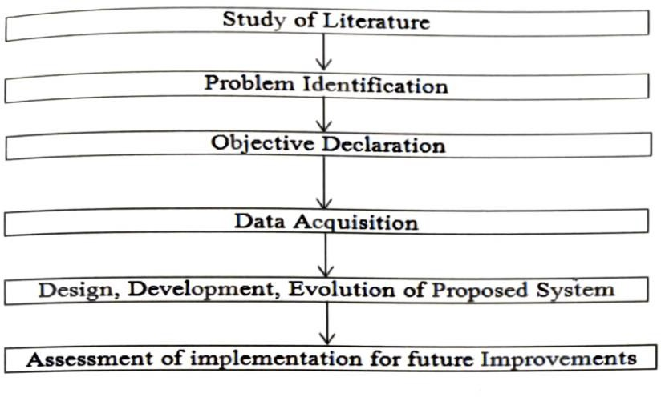
Figure 1. Research Methodology

CHAPTER- 8

INNOVATION

In the pursuit of creating an advanced and user-centric posture monitoring system, this project introduces a multifaceted approach aimed at revolutionizing the telecommuting experience. Firstly, by integrating Augmented Reality (AR) technology, the system provides users with real-time visual feedback on their posture. This not only enhances the interactive experience but also makes corrective actions more engaging and immediate. The incorporation of AR adds a layer of immersion to the posture monitoring process, fostering a heightened awareness of body positioning during extended computer usage.

To further elevate the user experience, the project implements AI-driven adaptive recommendations. By leveraging artificial intelligence, the system tailors a personalized posture improvement plan based on individual habits. The recommendations dynamically adjust over time as the system learns from user behaviors, ensuring a customized and evolving approach to posture correction. This intelligent adaptation aligns with the project's commitment to providing not just corrective measures but also fostering long-term habits conducive to maintaining healthy posture.

Expanding beyond visual feedback, the project integrates wearable devices into the system. Smart clothing or accessories capture additional physiological data, providing a more comprehensive understanding of the user's well-being. This holistic monitoring approach enriches the posture analysis with physiological insights, contributing to a more nuanced understanding of the factors influencing an individual's posture during telecommuting.

Taking inspiration from gamification principles, the project introduces a gamified posture improvement experience. By transforming posture correction into a challenge or game, users are motivated to actively participate in maintaining good posture. Rewards and achievements create a positive reinforcement loop, enhancing user engagement and commitment to adopting and sustaining healthy posture habits.

Voice recognition technology is seamlessly integrated to elevate hands-free interaction. This feature enhances the user experience by enabling real-time feedback and adjustments without manual input, providing a convenient and accessible way for users to engage with the system while focusing on their work.

Virtual collaboration spaces are introduced within the system, facilitating communication between telecommuting employees. This not only fosters a sense of community but also allows users to share insights and support each other in maintaining healthy postures. The collaborative aspect enhances the social dimension of the telecommuting experience, promoting a supportive environment for overall well-being.

Stress level monitoring is integrated into the system, leveraging posture data to provide users with insights into how their work environment and posture may impact their overall well-being. This additional layer of analysis contributes to a holistic understanding of the interplay between physical posture and emotional states, offering users valuable insights into stress management.

The exploration of biofeedback mechanisms, such as haptic feedback or bio-sensors, adds a layer of immersion and responsiveness to the system. This investigation aims to create a more adaptive and interactive system that considers the user's physical and emotional state, further enhancing the overall effectiveness of posture correction.

To enhance accessibility, a user-friendly mobile application is developed to complement the hardware system. This application allows users to conveniently access posture data, recommendations, and progress reports on their smartphones, providing a seamless and portable extension of the overall posture monitoring experience.

The implementation of continuous learning algorithms ensures that the system adapts to changing work environments and habits. This feature guarantees the system's effectiveness in diverse telecommuting scenarios, aligning with the dynamic nature of modern work setups. Overall, this multifaceted approach signifies a commitment to innovation and user well-being, positioning the project as a trailblazer in the evolution of telecommuting posture monitoring systems.

5.2. INTRODCTUCTION TO COMPUTER VISION

The reliability and precision of computer vision encompasses several key components aimed at developing an intelligent system capable of accurately detecting and analyzing workplace posture in real time. The primary objective lies in crafting an intelligent system endowed with the capability to seamlessly detect and meticulously analyze various postural configurations prevalent in work environments. By harnessing advanced algorithms and machine learning techniques, the project seeks to empower this system to swiftly and accurately recognize an array of posture-related nuances, including seated, standing, or specific ergonomic positions. Moreover, the endeavor encompasses the development of robust methodologies for pose estimation, which entails deciphering the spatial arrangement and orientation of key anatomical landmarks such as the head, shoulders, spine, and limbs.

As an illustration, consider the following instances of well-known computer vision tasks: -

5.2.1. Image acquisition: -
In the phase of image acquisition, advanced camera systems or sensors are strategically deployed to capture high-resolution images or videos of individuals in their respective workplace settings. These sophisticated imaging technologies are meticulously calibrated to ensure optimal coverage and clarity, enabling the system to effectively capture and document various postural nuances and dynamics as individuals engage in their work activities.

5.2.2. Object detection: -
Prior to identifying and tabulating an object's appearance in an image or video, image classification may be used to determine a certain picture class. A production line that has been damaged or a piece of equipment that has to be repaired are two examples.

5.2.3. Object tracking: -
Tracking an object once it has been discovered is known as object following. Photos and videos are often utilised in this kind of activity.

Figure 2. Flow of Posture Detection

5.2.4. Posture Detection:-
Posture detection within the "Smart System for Workplace Posture Monitoring" project involves the utilization of advanced computer vision algorithms, notably deep learning-based convolutional neural networks (CNNs). These algorithms are adept at discerning and categorizing a multitude of postures observed in workplace settings, encompassing variations such as sitting, standing, as well as specialized ergonomic positions tailored for optimal comfort and health. Through meticulous analysis and pattern recognition, the system can accurately interpret and classify diverse postural configurations in real-time scenarios, thereby facilitating comprehensive posture monitoring and analysis.

5.2.2.2. SUB-DOMAIN: -

5.2.2.2.1. Pose Estimation: -

Pose Estimation is a pivotal aspect within the computer vision domain of the project, entailing the meticulous determination of the spatial arrangement and orientation of critical body parts, including the head, shoulders, spine, and limbs. This process serves as a cornerstone for evaluating the correctness and alignment of posture, providing essential insights into ergonomic health and facilitating the accurate assessment of individuals' overall physical well-being within the workplace environment.

5.2.2.2.2. Feature Extraction:-
In the feature extraction phase, pertinent attributes are gleaned from images or video frames, including joint angles, distinctive body landmarks, and silhouette traits. These extracted features serve as crucial inputs for quantifying posture metrics and discerning deviations from established ergonomic standards. By meticulously analyzing these characteristics, the system gains insights into the subtleties of posture dynamics, enabling it to provide tailored recommendations for improving ergonomic practices and mitigating potential health risks.

5.2.2.2.3. WORKFLOW OF THE POSTURE DETECTION:
An initial research phase to gather insights into existing posture monitoring technologies, ergonomic standards, and prevalent issues in workplace posture. Following this, the project moves into the design phase, where specifications for the sensor-based application are outlined, considering factors such as sensor placement, data collection methods, and user interface design. Next, the development stage involves the creation of hardware components, including sensors capable of detecting posture deviations, and software algorithms for real-time data processing and analysis. Concurrently, efforts are made to ensure seamless integration between the hardware and software components, facilitating efficient communication and data transfer. Once the system is fully developed, rigorous testing and validation procedures are conducted to assess its accuracy, reliability, and user-friendliness in real-world workplace environments. Feedback from test users and stakeholders is incorporated into iterative improvements, refining the system's performance and usability. Finally, deployment strategies are devised to introduce the smart posture monitoring system into various workplace settings, accompanied by comprehensive training programs to educate users on its functionalities and benefits. Ongoing monitoring and maintenance protocols are established to support the continued functionality and optimization of the system over time.

Figure 3. Key Points in the Human Body

5.2.2.2.3.1. Posture Monitoring Applications:
The smart system for workplace posture monitoring offers a range of practical applications aimed at improving occupational health and productivity in various work settings. Firstly, it provides real-time monitoring of employees' posture, offering immediate feedback and guidance to promote correct ergonomic positioning. This proactive approach helps prevent musculoskeletal issues, such as back and neck pain, which are common among office workers. Additionally, the system can generate detailed reports and analytics on posture trends over time, enabling employers to identify high-risk areas and implement targeted interventions or ergonomic improvements in the workplace layout or furniture design. Furthermore, the data collected by the system can contribute to broader health and safety initiatives within organizations, facilitating evidence-based decision-making and fostering a culture of employee well-being. Overall, the smart system for workplace posture monitoring offers a comprehensive solution to support healthy and productive work environments.

5.2.2.2.3.2. Posture Detection Algorithms:
The smart system for workplace posture monitoring employs several algorithms to accurately detect and analyze individuals' postures in real-time. Initially, the system utilizes computer vision algorithms, such as convolutional neural networks (CNNs), to process live video feeds from cameras positioned in the workplace. These algorithms identify key body landmarks and joint angles, enabling the system to determine the user's posture with high precision. Subsequently, the detected postures are compared against predefined ergonomic guidelines using rule-based algorithms. This step involves assessing factors such as the alignment of the spine, positioning of the shoulders, and distribution of weight on the chair. Based on this analysis, the system generates personalized recommendations and alerts in real-time to encourage users to adopt healthier postures.

Additionally, machine learning algorithms continuously refine the system's posture detection capabilities by learning from user feedback and adjusting posture classification criteria accordingly. Overall, this combination of computer vision, rule-based, and machine learning algorithms forms the backbone of the smart system for workplace posture monitoring, ensuring accurate detection and proactive intervention to promote better ergonomic practices and reduce the risk of musculoskeletal disorders.

- Convolutional Neural Network (CNN)
- Data Acquisition
- Posture Detection
- Real Time Monitoring
- Alerting Mechanism
- User Feedback and Intervention
- Data Storage and Analysis

5.2.2.2.3.2.1. CONVOLUTIONAL NEURAL NETWORK(CNN):
The convolutional neural network (CNN) is a major advancement in artificial neural networks (ANN) and artificial intelligence (AI) research (CNN). The most popular deep learning approach teaches a model to do classification tasks on images, videos, texts or sounds by observing how they change over time. [26]
Model (ImageNet) supports a wide variety of applications, including computer vision, natural language processing (NLP) and the world's largest image classification data. There are two additional layers to the typical neural network: convolutional and pooling. Hundreds or thousands of these layers may be found in a CNN, and each one learns to recognise unique visual properties.

5.2.2.2.3.2.2. DATA ACQUISITION:
In the data acquisition phase, the smart system for workplace posture monitoring relies on sensors or cameras to capture relevant data concerning posture, with a particular focus on key body parts such as the neck, shoulders, and back. Algorithms are then employed to preprocess and filter the raw sensor data, effectively eliminating noise and irrelevant information. This critical step ensures that the subsequent analysis is based on high-quality, reliable data, enabling accurate detection and assessment of workplace posture. By optimizing data acquisition techniques, the system can provide users with actionable insights and interventions to promote ergonomic well-being in the workplace.

5.2.2.2.3.2.2.1. POSTURE DETECTION:
The posture detection algorithm employs a multi-stage approach utilizing convolutional neural networks (CNNs) and keypoint extraction. Initially, the input image undergoes preprocessing, including resizing and padding. Subsequently, the VGG model extracts features, followed by several stages of processing to refine predictions. Each stage refines the detection using both heatmaps and part affinity fields (PAFs) generated by the network. Finally, angles between body parts and distances between keypoints are calculated to determine the posture. The algorithm's workflow involves iteratively refining predictions through multiple stages, culminating in a comprehensive assessment of the subject's posture based on the detected keypoints and their spatial relationships.

In real-time posture detection, the algorithm processes video frames sequentially, applying the posture detection methodology to each frame individually. The workflow involves capturing a video frame, preprocessing it to meet the input requirements of the convolutional neural network (CNN), and then passing it through the network for inference. The CNN extracts features and generates heatmaps and part affinity fields (PAFs) representing keypoint locations and their connections. Gaussian filtering and peak detection identify keypoint locations, which are then used to estimate joint positions and infer posture. This process repeats for each frame of the video, allowing for continuous real-time posture detection. The efficiency of the algorithm ensures that posture can be detected and analyzed with minimal delay, enabling applications such as real-time feedback on body positioning or monitoring during physical activities.
5.2.2.2.3.3. ALERTING MECHANISM:
The alerting mechanism is a pivotal component of the posture monitoring system, ensuring timely intervention when poor posture is detected over an extended duration. By defining thresholds or criteria for identifying the severity and duration of incorrect postures, the system can precisely determine when alerts should be triggered. Moreover, it encompasses various communication channels, such as visual alerts on the user interface, audible alarms, or mobile notifications, tailored to suit user preferences and ensure effective delivery of alerts. This multi-faceted approach enhances user awareness of their posture habits, facilitating prompt corrective action to mitigate the risk of musculoskeletal issues.
2.3.4. USER FEEDBACK AND INTERVENTION:
In the realm of user feedback and intervention, the development of sophisticated algorithms plays a pivotal role. These algorithms are crafted to deliver actionable feedback and intervention strategies directly to users, fostering awareness and facilitating proactive posture improvement. By offering personalized recommendations tailored to individual needs, including ergonomic adjustments and targeted exercises, the system empowers users to optimize their workspace ergonomics effectively. Leveraging machine learning techniques, the system continuously refines its feedback mechanisms, adapting to each user's unique characteristics and preferences over time.
2.3.5. DATA STORAGE AND ANALYSIS:
In the realm of data storage and analysis, it is imperative to establish robust mechanisms for securely and efficiently storing posture data. This entails careful consideration of various factors, including data volume, privacy concerns, and compliance requirements to ensure adherence to relevant regulations. Additionally, implementing sophisticated analytics algorithms is crucial for deriving actionable insights from aggregated posture data. These algorithms enable the identification of trends, correlations, and patterns pertinent to workplace posture habits, empowering stakeholders to make informed decisions and implement targeted interventions aimed at promoting better ergonomic practices and mitigating the risk of musculoskeletal disorders.

2.3. LIMITATION OF FACIAL RECOGNITION:
Despite its innovative approach, the smart system for workplace posture monitoring encounters several limitations. Firstly, the reliance on camera may impede its effectiveness as they might not capture all subtleties of posture accurately, especially in dynamic work settings where movements are frequent and varied. Moreover, technological constraints or latency issues could limit the system's ability to provide real-time feedback and corrective measures, reducing its immediate utility for users seeking timely adjustments. Additionally, while the system targets posture improvement, it may not comprehensively address all ergonomic factors contributing to poor posture, such as environmental conditions or individual habits, potentially limiting its overall impact. Furthermore, the implementation of such a system may encounter resistance or privacy concerns from users wary of constant monitoring of their workplace behavior, posing challenges to widespread adoption. Finally, the efficacy of the system hinges significantly on user compliance and engagement, as sustained usage and adherence to corrective recommendations are crucial for achieving long-term posture improvement goals. Addressing these limitations will be paramount to enhancing the system's efficacy and fostering its acceptance and integration within diverse workplace environments.

2.4. DRAWBACK OF FACIAL RECOGNITION:
While the project title "Smart System for Workplace Posture Monitoring" promises innovation and potential advantages, it's essential to acknowledge several potential drawbacks that require careful consideration. Firstly, the title suggests a narrow focus solely on workplace posture monitoring, potentially neglecting crucial aspects of occupational health and ergonomics, such as workstation setup, regular movement breaks, and overall well-being. Secondly, the reliance on a "smart system" may inadvertently exclude individuals who lack access to or are uncomfortable with technology, leaving them without adequate posture monitoring solutions. Moreover, the involvement of smart systems often entails data collection and analysis, raising legitimate concerns regarding privacy and data security, particularly when sensitive health information is involved. This could result in user hesitancy to adopt the system due to perceived privacy risks. Additionally, implementing a sophisticated smart system may require substantial investment in hardware, software, and maintenance, potentially rendering it inaccessible to smaller businesses or individuals with limited resources. Furthermore, while smart systems for posture monitoring offer convenience, they may not always deliver accurate or reliable data, leading to false alarms or missed posture issues, which can undermine user trust and satisfaction. Employee acceptance may also pose a challenge, as constant monitoring of their posture might be perceived as intrusive or overly controlling, leading to resistance or non-compliance with the system's recommendations. Lastly, a purely technological solution lacks the personalized feedback and guidance that a human ergonomic specialist can provide, potentially limiting its effectiveness in addressing individual needs and preferences. Thus, while the proposed smart system holds promise, it's crucial to address these potential drawbacks to ensure its successful implementation and acceptance in workplace environments.
- Limited Scope.
- Dependency on Technology.
- Privacy Concerns.
- Lack of Human Touch.
- Cost.

5.3. SCOPE AND APPLICATION

- Telecommuting Workforce Wellness:

- Scope: The project endeavors to improve the well-being of the telecommuting workforce, specifically targeting ergonomic challenges and potential health issues arising from prolonged computer usage.

- Application: Primarily designed for individuals working remotely, the system delivers real-time feedback and recommendations to foster healthier posture habits during the course of their work.

- Occupational Risk Prevention:

- Scope: With a focus on occupational risk prevention in the medical sector, the project actively identifies and quantifies incorrect postures in telecommuting employees.

- Application: Offering a proactive strategy, the system plays a pivotal role in preventing musculoskeletal issues and other health concerns associated with poor posture during remote work scenarios.

- Automated Posture Detection and Analysis:

- Scope: The primary goal is the development of an automated tool for detecting and analyzing the posture of telecommuters, eliminating the need for manual intervention.

- Application: Versatile across various work settings, the system provides a hands-free solution for continuous posture monitoring, ensuring adaptability to diverse professional environments.

- Specialized Hardware and Convolutional Neural Networks (CNNs):

- Scope: Leveraging specialized hardware and CNNs guarantees efficient real-time video processing, a crucial element for accurate posture detection.

- Application: Deployable across diverse telecommuting setups, the system utilizes dedicated hardware to achieve high processing speeds, ensuring accuracy and reliability.

- Real-time Video Processing:

- Scope: The project demonstrates the feasibility of real-time video processing, achieving up to 25 frames per second for instant feedback on posture.

- Application: Relevant to telecommuters across various industries, the system ensures timely adjustments to prevent prolonged incorrect postures, contributing to overall well-being.

- Low Power Consumption:

- Scope: Minimizing power consumption (below 10 watts) enhances sustainability and usability over extended periods, aligning with eco-friendly considerations.

- Application: Suitable for continuous use during work hours, the system has minimal impact on the user's device, promoting energy efficiency and prolonged usage.

- Accuracy in Posture Detection:

- Scope: Achieving an accuracy rate exceeding 80% ensures the system's reliability and effectiveness in identifying incorrect postures.

- Application: A trustworthy tool for feedback, the system contributes to long-term posture improvement, playing a vital role in enhancing overall health and well-being.

- Potential for Remote Health Monitoring:

- Scope: The project opens avenues for potential expansion into remote health monitoring by capturing posture-related data and its broader impact on overall health.

- Application: The system could evolve to encompass a range of health metrics, providing a comprehensive view of the telecommuter's health status beyond posture alone.

- Integration with Existing Work Environments:

- Scope: The system seamlessly integrates into various telecommuting environments, showcasing adaptability to diverse workstations.

- Application: With the evolving nature of remote work, the system remains effective across different industries and job roles, accommodating the diverse needs of telecommuters.

- User-friendly Implementation:

- Scope: Prioritizing a user-friendly implementation, the project explores the potential for mobile applications, ensuring easy access to posture data and recommendations.

- Application: The user-centric design promotes widespread adoption, making the system accessible and usable across different demographics, contributing to its overall effectiveness.

CHAPTER- 11

ARCHITECTURE

The Smart System for Workplace Posture Monitoring proposes an architecture comprising sensor integration, data collection, processing, and analysis, posture monitoring and feedback mechanisms, integration with user interfaces, privacy and security considerations, and scalability and adaptability features. The architecture used in the provided code for monitoring posture typically involves a convolutional neural network (CNN) for keypoint detection and pose estimation. Specifically, the code may utilize variants of popular architectures such as OpenPose, PoseNet, or Hourglass Networks. These architectures consist of multiple convolutional layers for feature extraction and may incorporate additional components like skip connections, pooling layers, and residual blocks to enhance performance. The CNN architecture is trained on large datasets annotated with keypoint locations to learn to detect body joints and infer body pose from input images or frames. Additionally, post-processing techniques such as Gaussian filtering, peak detection, and keypoint association are often employed to refine keypoint predictions and generate accurate pose estimates. Overall, these architectures enable robust and efficient posture monitoring in real-time applications. The Smart System for Workplace Posture Monitoring represents a groundbreaking approach to enhancing workplace ergonomics and ensuring the well-being of employees through the innovative utilization of computer vision technology. At its core, this system relies on strategically positioned cameras to continuously monitor and analyze the posture of individuals within the workplace environment. By leveraging advanced image processing techniques and deep learning algorithms, the system can accurately detect improper postures in real-time, providing timely feedback and suggestions to users to promote better posture habits and mitigate the risk of musculoskeletal disorders.
The architecture of this system is meticulously designed to encompass various components, each playing a crucial role in its functionality and effectiveness. The first pillar of the architecture lies in the camera setup, where multiple cameras are strategically positioned throughout the workplace to ensure comprehensive coverage. These cameras, equipped with suitable resolution and frame rates, capture live video feeds of the workspace, which are then processed in real-time to extract posture-related information.
Prior to pose detection, raw video frames undergo pre-processing to enhance quality and reduce noise, ensuring optimal performance of the system. Techniques such as image stabilization and background subtraction are employed to isolate individuals and minimize interference, thereby facilitating more accurate posture analysis.
Pose detection, a pivotal component of the system, utilizes deep learning models such as Convolutional Neural Networks (CNNs) to estimate and track the posture of individuals within the workspace. By analyzing each frame and detecting key points corresponding to joints and body parts, these models enable the system to identify and classify postures based on predefined ergonomic guidelines. Machine learning algorithms further refine this process by categorizing postures as ergonomic or non-ergonomic, allowing for real-time feedback and alerts when improper postures are detected.
The captured posture data, including timestamps and corresponding video frames, are securely stored in a database for further analysis and visualization. Analytics tools enable users to explore posture trends over time, providing valuable insights that can inform ergonomic improvements in workplace layout and practices. Additionally, a user-friendly interface grants users access to real-time posture feedback, historical data, and customizable settings, enhancing usability and facilitating user engagement.
Security and privacy considerations are paramount in the design of this system, with robust measures implemented to protect sensitive data captured by the cameras. Anonymization techniques and compliance with relevant regulations, such as GDPR, ensure that user privacy is safeguarded at all times.
Finally, calibration and maintenance protocols are put in place to ensure the accuracy and reliability of the system. Periodic calibration of cameras and pose detection models, coupled with regular maintenance checks, help address any hardware or software issues promptly, ensuring uninterrupted operation of the system.
In conclusion, the Smart System for Workplace Posture Monitoring represents a holistic approach to promoting healthy posture habits in the workplace, integrating camera technology, computer vision algorithms, and user interfaces to enhance ergonomics, employee well-being, and productivity. By continuously monitoring and analyzing posture data, this system has the potential to revolutionize workplace environments, fostering a culture of wellness and productivity.

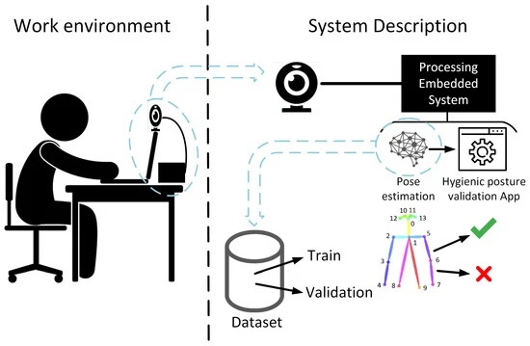
Figure 4. Architecture Diagram

6.3. PROPOSED MODULES

- Data Acquisition Module:

- Responsible for collecting real-time video data from the user's workstation, focusing on the neck, shoulders, and arms to capture posture-related information.

2. Specialized Hardware Integration:

- Integrates and manages the specialized hardware components necessary for posture detection, ensuring seamless communication between sensors and the central processing unit.

3. Convolutional Neural Network (CNN) Implementation:

- Develops and implements the CNN-based algorithm for posture detection, training the network to recognize and classify different postures based on the acquired video data.

4. Real-time Video Processing Module:

- Utilizes efficient algorithms for real-time video processing, achieving processing speeds of up to 25 frames per second to provide instant feedback on the user's posture.

- Posture Analysis and Classification:

- Analyzes the processed video data to identify the posture of the neck, shoulders, and arms, classifying them into predefined categories representing correct or incorrect postures.

- User Feedback and Recommendations:

- Offers personalized recommendations to the user based on the detected posture, encouraging corrective actions to prevent potential health issues arising from prolonged incorrect postures.

- Power Management Module:

- Monitors and manages the power consumption of the system, ensuring it operates below 10 watts to optimize energy efficiency during extended periods of use.

- User Interface Development:

- Designs a user-friendly interface, potentially in the form of a mobile application or desktop dashboard, to display posture data, recommendations, and overall system feedback.

- Continuous Learning Algorithm:

- Implements an algorithm that allows the system to continuously learn and adapt to the user's changing postural habits over time, enhancing accuracy and personalization.

- Privacy and Security Module:

- Ensures the privacy and security of user data, implementing encryption and secure data transmission protocols to safeguard sensitive information collected during posture monitoring.

7. Remote Monitoring and Analytics:

- Develops capabilities for remote monitoring, allowing healthcare professionals or designated individuals to access posture data for analytics and intervention if necessary.

- Long-Term Impact Assessment Module:

- Integrates a module to assess the long-term impact of the system on user health, collecting data over extended periods and analyzing trends posture correction strategies.

CHAPTER- 14

TRAINING AND VALIDATION

The training and validation model used in the provided code for monitoring posture likely involves a combination of data preprocessing, model architecture selection, and training/validation procedures. Firstly, the dataset is preprocessed to normalize, augment, and prepare the images or video frames for training. Then, a convolutional neural network (CNN) architecture, such as OpenPose, PoseNet, or Hourglass Networks, is chosen for its effectiveness in keypoint detection and pose estimation. The model architecture typically comprises multiple convolutional layers followed by activation functions, pooling layers, and possibly skip connections or residual blocks to capture hierarchical features. During training, the model is optimized using techniques like stochastic gradient descent (SGD) or Adam with a suitable loss function such as mean squared error (MSE) or a combination of classification and regression losses. Validation is performed on a separate portion of the dataset to monitor the model's generalization performance and fine-tune hyperparameters to prevent overfitting. Techniques like early stopping and learning rate scheduling may also be employed to improve training efficiency and convergence. Overall, this approach provides a systematic framework for training and validating posture monitoring models in research papers.

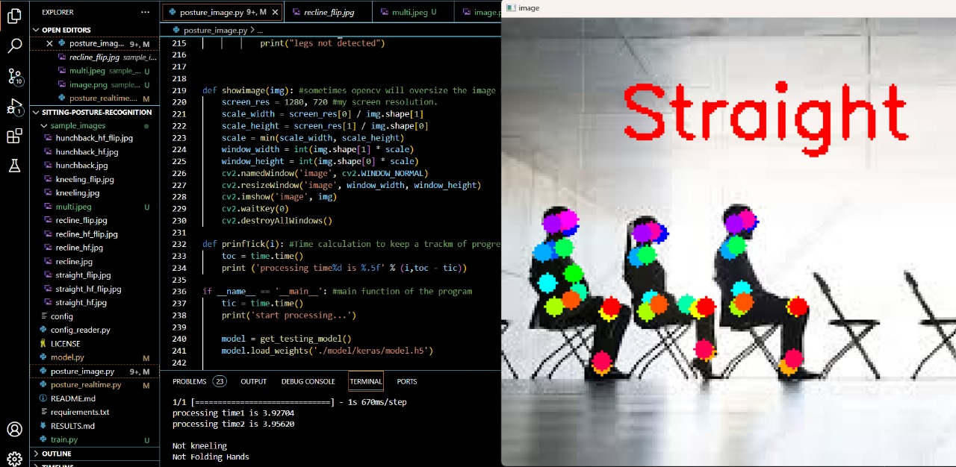
Figure 5. Straight Posture
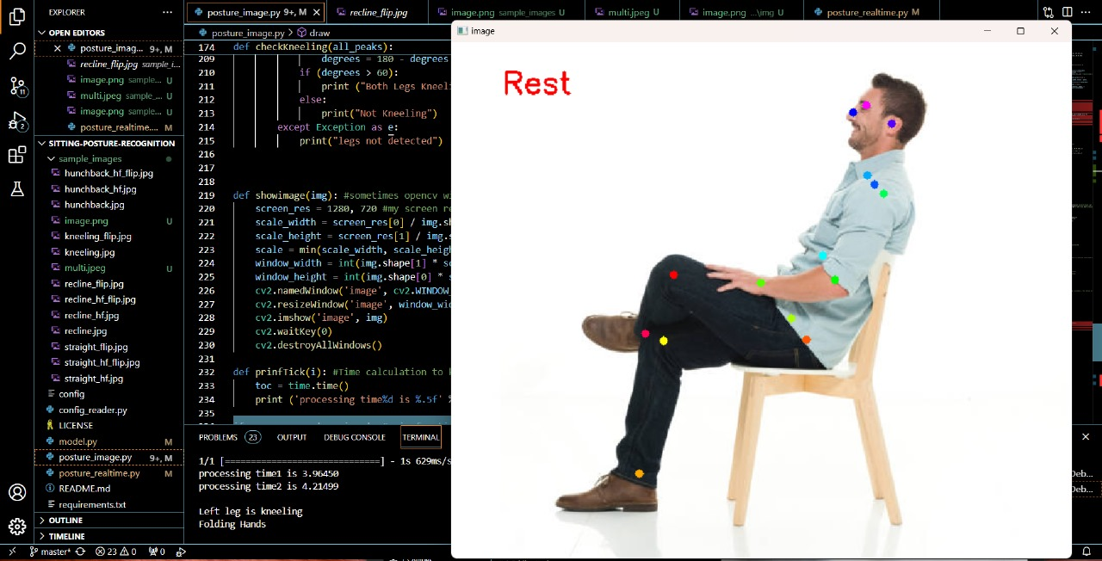
Figure 6. Rest Posture

  - ALGORITHM DESCRIPTION

- Data Acquisition:

- Collect real-time video data from the telecommuter’s workstation, focusing on the areas of the neck, shoulders, and arms.

- Preprocessing:

- Apply preprocessing techniques to enhance the quality of the video data, including noise reduction, frame normalization, and background subtraction.

- Frame Segmentation:

- Divide the video stream into individual frames for efficient processing and analysis.

- Specialized Hardware Initialization:

- Initialize the specialized hardware components, ensuring proper communication and synchronization with the central processing unit.

- Convolutional Neural Network (CNN) Loading:

- Load the trained CNN model designed for posture detection, ensuring that the model is ready for real-time inference.

- Real-time Video Processing:

- Implement algorithms for real-time video processing, achieving speeds of up to 25 frames per second to maintain instant feedback on posture.

- Posture Identification:

- Apply the CNN to each frame to identify and classify the posture of the neck, shoulders, and arms into predefined categories (e.g., correct or incorrect postures).

- Accuracy Assessment:

- Evaluate the accuracy of posture detection by comparing the CNN predictions with ground truth data from abelled frames in the training dataset.

- Recommendation Generation:

- Based on the identified posture, generate personalized recommendations to guide the telecommuter in making corrective adjustments to prevent potential health issues.

- Power Consumption Monitoring:

- Continuously monitor the power consumption of the system to ensure it remains below 10 watts, optimizing energy efficiency during prolonged usage.

- User Interface Update:

- Update the user interface, displaying real-time feedback, posture classifications, and recommendations for the telecommuter’s awareness and engagement.

- Continuous Learning Mechanism:

- Implement algorithms for continuous learning, allowing the system to adapt and improve its posture detection capabilities over time based on user behavior.

- Privacy Measures:

- Integrate encryption and secure data transmission protocols to safeguard user privacy and ensure the confidentiality of posture-related data.

- Remote Monitoring Integration:

- Establish capabilities for remote monitoring, allowing authorized healthcare professionals or designated individuals to access posture data for analytics and intervention.

- Long-Term Impact Assessment:

- Develop algorithms to assess the long-term impact of the system on user health, analyzing trends in posture data collected over extended periods for evaluation.

7.3 UML DIAGRAMS

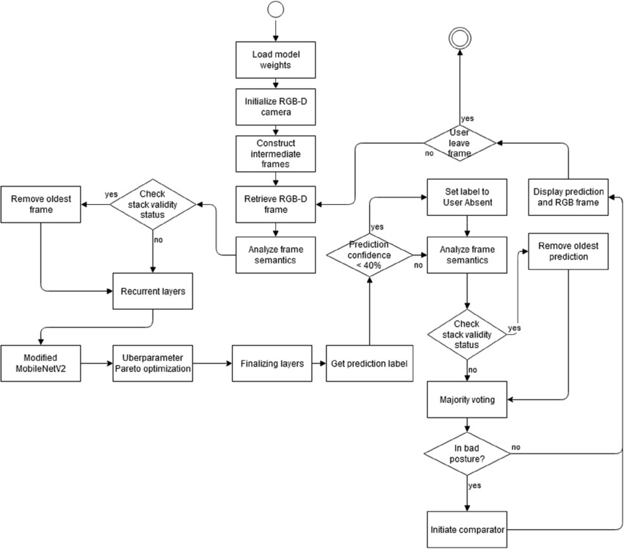
Figure 7. UML Diagram

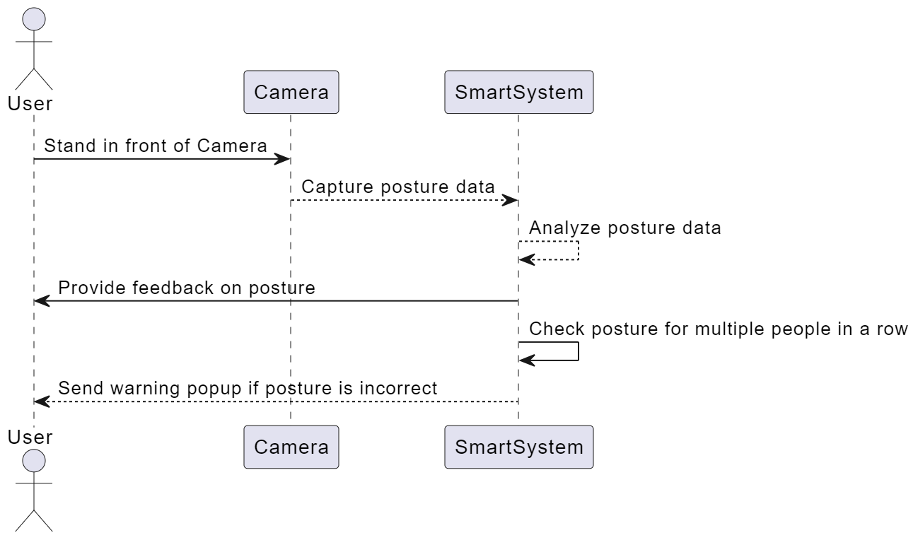
Figure 8. Sequence Diagram

CHAPTER- 17

CODE IMPLEMENTATION

model.py

from keras.models import Model
from keras.layers import Concatenate
from keras.layers import Activation, Input, Lambda
from keras.layers import Conv2D
from keras.layers import MaxPooling2D
from keras.layers import Multiply
from keras.regularizers import l2
from keras.initializers import random_normal,constant

def relu(x): return Activation('relu')(x)

def conv(x, nf, ks, name, weight_decay):
kernel_reg = l2(weight_decay[0]) if weight_decay else None
bias_reg = l2(weight_decay[1]) if weight_decay else None

x = Conv2D(nf, (ks, ks), padding='same', name=name,
kernel_regularizer=kernel_reg,
bias_regularizer=bias_reg,
kernel_initializer=random_normal(stddev=0.01),
bias_initializer=constant(0.0))(x)
return x

def pooling(x, ks, st, name):
x = MaxPooling2D((ks, ks), strides=(st, st), name=name)(x)
return x

def vgg_block(x, weight_decay):
# Block 1
x = conv(x, 64, 3, "conv1_1", (weight_decay, 0))
x = relu(x)
x = conv(x, 64, 3, "conv1_2", (weight_decay, 0))
x = relu(x)
x = pooling(x, 2, 2, "pool1_1")

# Block 2
x = conv(x, 128, 3, "conv2_1", (weight_decay, 0))
x = relu(x)
x = conv(x, 128, 3, "conv2_2", (weight_decay, 0))
x = relu(x)
x = pooling(x, 2, 2, "pool2_1")

# Block 3
x = conv(x, 256, 3, "conv3_1", (weight_decay, 0))
x = relu(x)
x = conv(x, 256, 3, "conv3_2", (weight_decay, 0))
x = relu(x)
x = conv(x, 256, 3, "conv3_3", (weight_decay, 0))
x = relu(x)
x = conv(x, 256, 3, "conv3_4", (weight_decay, 0))
x = relu(x)
x = pooling(x, 2, 2, "pool3_1")

# Block 4
x = conv(x, 512, 3, "conv4_1", (weight_decay, 0))
x = relu(x)
x = conv(x, 512, 3, "conv4_2", (weight_decay, 0))
x = relu(x)

# Additional non vgg layers
x = conv(x, 256, 3, "conv4_3_CPM", (weight_decay, 0))
x = relu(x)
x = conv(x, 128, 3, "conv4_4_CPM", (weight_decay, 0))
x = relu(x)

return x

def stage1_block(x, num_p, branch, weight_decay):
# Block 1
x = conv(x, 128, 3, "Mconv1_stage1_L%d" % branch, (weight_decay, 0))
x = relu(x)
x = conv(x, 128, 3, "Mconv2_stage1_L%d" % branch, (weight_decay, 0))
x = relu(x)
x = conv(x, 128, 3, "Mconv3_stage1_L%d" % branch, (weight_decay, 0))
x = relu(x)
x = conv(x, 512, 1, "Mconv4_stage1_L%d" % branch, (weight_decay, 0))
x = relu(x)
x = conv(x, num_p, 1, "Mconv5_stage1_L%d" % branch, (weight_decay, 0))

return x

def stageT_block(x, num_p, stage, branch, weight_decay):
# Block 1
x = conv(x, 128, 7, "Mconv1_stage%d_L%d" % (stage, branch), (weight_decay, 0))
x = relu(x)
x = conv(x, 128, 7, "Mconv2_stage%d_L%d" % (stage, branch), (weight_decay, 0))
x = relu(x)
x = conv(x, 128, 7, "Mconv3_stage%d_L%d" % (stage, branch), (weight_decay, 0))
x = relu(x)
x = conv(x, 128, 7, "Mconv4_stage%d_L%d" % (stage, branch), (weight_decay, 0))
x = relu(x)
x = conv(x, 128, 7, "Mconv5_stage%d_L%d" % (stage, branch), (weight_decay, 0))
x = relu(x)
x = conv(x, 128, 1, "Mconv6_stage%d_L%d" % (stage, branch), (weight_decay, 0))
x = relu(x)
x = conv(x, num_p, 1, "Mconv7_stage%d_L%d" % (stage, branch), (weight_decay, 0))

return x

def apply_mask(x, mask1, mask2, num_p, stage, branch):
w_name = "weight_stage%d_L%d" % (stage, branch)
if num_p == 38:
w = Multiply(name=w_name)([x, mask1]) # vec_weight

else:
w = Multiply(name=w_name)([x, mask2]) # vec_heat
return w

def get_training_model(weight_decay):

stages = 6
np_branch1 = 38
np_branch2 = 19

img_input_shape = (None, None, 3)
vec_input_shape = (None, None, 38)
heat_input_shape = (None, None, 19)

inputs = []
outputs = []

img_input = Input(shape=img_input_shape)
vec_weight_input = Input(shape=vec_input_shape)
heat_weight_input = Input(shape=heat_input_shape)

inputs.append(img_input)
inputs.append(vec_weight_input)
inputs.append(heat_weight_input)

img_normalized = Lambda(lambda x: x / 256 - 0.5)(img_input) # [-0.5, 0.5]

# VGG
stage0_out = vgg_block(img_normalized, weight_decay)

# stage 1 - branch 1 (PAF)
stage1_branch1_out = stage1_block(stage0_out, np_branch1, 1, weight_decay)
w1 = apply_mask(stage1_branch1_out, vec_weight_input, heat_weight_input, np_branch1, 1, 1)

# stage 1 - branch 2 (confidence maps)
stage1_branch2_out = stage1_block(stage0_out, np_branch2, 2, weight_decay)
w2 = apply_mask(stage1_branch2_out, vec_weight_input, heat_weight_input, np_branch2, 1, 2)

x = Concatenate()([stage1_branch1_out, stage1_branch2_out, stage0_out])

outputs.append(w1)
outputs.append(w2)

# stage sn >= 2
for sn in range(2, stages + 1):
# stage SN - branch 1 (PAF)
stageT_branch1_out = stageT_block(x, np_branch1, sn, 1, weight_decay)
w1 = apply_mask(stageT_branch1_out, vec_weight_input, heat_weight_input, np_branch1, sn, 1)

# stage SN - branch 2 (confidence maps)
stageT_branch2_out = stageT_block(x, np_branch2, sn, 2, weight_decay)
w2 = apply_mask(stageT_branch2_out, vec_weight_input, heat_weight_input, np_branch2, sn, 2)

outputs.append(w1)
outputs.append(w2)

if (sn < stages):
x = Concatenate()([stageT_branch1_out, stageT_branch2_out, stage0_out])

model = Model(inputs=inputs, outputs=outputs)

return model

def get_testing_model():
stages = 6
np_branch1 = 38
np_branch2 = 19

img_input_shape = (None, None, 3)

img_input = Input(shape=img_input_shape)

img_normalized = Lambda(lambda x: x / 256 - 0.5)(img_input) # [-0.5, 0.5]

# VGG
stage0_out = vgg_block(img_normalized, None)

# stage 1 - branch 1 (PAF)
stage1_branch1_out = stage1_block(stage0_out, np_branch1, 1, None)

# stage 1 - branch 2 (confidence maps)
stage1_branch2_out = stage1_block(stage0_out, np_branch2, 2, None)

x = Concatenate()([stage1_branch1_out, stage1_branch2_out, stage0_out])

# stage t >= 2
stageT_branch1_out = None
stageT_branch2_out = None
for sn in range(2, stages + 1):
stageT_branch1_out = stageT_block(x, np_branch1, sn, 1, None)
stageT_branch2_out = stageT_block(x, np_branch2, sn, 2, None)

if (sn < stages):
x = Concatenate()([stageT_branch1_out, stageT_branch2_out, stage0_out])

model = Model(inputs=[img_input], outputs=[stageT_branch1_out, stageT_branch2_out])

return model

image.py

import cv2
import math
import time
import numpy as np
import util
from config_reader import config_reader
from scipy.ndimage import gaussian_filter
from model import get_testing_model

tic=0
# visualize
colors = [[255, 0, 0], [255, 85, 0], [255, 170, 0], [255, 255, 0], [170, 255, 0], [85, 255, 0],
[0, 255, 0], \
[0, 255, 85], [0, 255, 170], [0, 255, 255], [0, 170, 255], [0, 85, 255], [0, 0, 255],
[85, 0, 255], \
[170, 0, 255], [255, 0, 255], [255, 0, 170], [255, 0, 85]]

def process (input_image, params, model_params):
''' Start of finding the Key points of full body using Open Pose.'''
oriImg = cv2.imread(input_image) # B,G,R order
multiplier = [x * model_params['boxsize'] / oriImg.shape[0] for x in params['scale_search']]
heatmap_avg = np.zeros((oriImg.shape[0], oriImg.shape[1], 19))
paf_avg = np.zeros((oriImg.shape[0], oriImg.shape[1], 38))
for m in range(1):
scale = multiplier[m]
imageToTest = cv2.resize(oriImg, (0, 0), fx=scale, fy=scale, interpolation=cv2.INTER_CUBIC)
imageToTest_padded, pad = util.padRightDownCorner(imageToTest, model_params['stride'],
model_params['padValue'])
input_img = np.transpose(np.float32(imageToTest_padded[:,:,:,np.newaxis]), (3,0,1,2)) # required shape (1, width, height, channels)
output_blobs = model.predict(input_img)
heatmap = np.squeeze(output_blobs[1]) # output 1 is heatmaps
heatmap = cv2.resize(heatmap, (0, 0), fx=model_params['stride'], fy=model_params['stride'],
interpolation=cv2.INTER_CUBIC)
heatmap = heatmap[:imageToTest_padded.shape[0] - pad[2], :imageToTest_padded.shape[1] - pad[3],
:]
heatmap = cv2.resize(heatmap, (oriImg.shape[1], oriImg.shape[0]), interpolation=cv2.INTER_CUBIC)
paf = np.squeeze(output_blobs[0]) # output 0 is PAFs
paf = cv2.resize(paf, (0, 0), fx=model_params['stride'], fy=model_params['stride'],
interpolation=cv2.INTER_CUBIC)
paf = paf[:imageToTest_padded.shape[0] - pad[2], :imageToTest_padded.shape[1] - pad[3], :]
paf = cv2.resize(paf, (oriImg.shape[1], oriImg.shape[0]), interpolation=cv2.INTER_CUBIC)
heatmap_avg = heatmap_avg + heatmap / len(multiplier)
paf_avg = paf_avg + paf / len(multiplier)

all_peaks = [] #To store all the key points which a re detected.
peak_counter = 0

prinfTick(1) #prints time required till now.

for part in range(18):
map_ori = heatmap_avg[:, :, part]
map = gaussian_filter(map_ori, sigma=3)

map_left = np.zeros(map.shape)
map_left[1:, :] = map[:-1, :]
map_right = np.zeros(map.shape)
map_right[:-1, :] = map[1:, :]
map_up = np.zeros(map.shape)
map_up[:, 1:] = map[:, :-1]
map_down = np.zeros(map.shape)
map_down[:, :-1] = map[:, 1:]

peaks_binary = np.logical_and.reduce(
(map >= map_left, map >= map_right, map >= map_up, map >= map_down, map > params['thre1']))
peaks = list(zip(np.nonzero(peaks_binary)[1], np.nonzero(peaks_binary)[0])) # note reverse
peaks_with_score = [x + (map_ori[x[1], x[0]],) for x in peaks]
id = range(peak_counter, peak_counter + len(peaks))
peaks_with_score_and_id = [peaks_with_score[i] + (id[i],) for i in range(len(id))]

all_peaks.append(peaks_with_score_and_id)
peak_counter += len(peaks)

connection_all = []
special_k = []
mid_num = 10

prinfTick(2) #prints time required till now.
print()
position = checkPosition(all_peaks) #check position of spine.
checkKneeling(all_peaks) #check whether kneeling oernot
checkHandFold(all_peaks) #check whether hands are folding or not.
canvas1 = draw(input_image,all_peaks, position) #show the image.
return canvas1 , position

def draw(input_image, all_peaks, position):
canvas = cv2.imread(input_image) # B,G,R order
for i in range(18):
for j in range(len(all_peaks[i])):
cv2.circle(canvas, all_peaks[i][j][0:2], 4, colors[i], thickness=-1)

# Adding text labels based on detected positions
if position == 1:
cv2.putText(canvas, "Hunchback", (50, 50), cv2.FONT_HERSHEY_SIMPLEX, 1, (0, 0, 255), 2)
elif position == -1:
cv2.putText(canvas, "Reclined", (50, 50), cv2.FONT_HERSHEY_SIMPLEX, 1, (0, 0, 255), 2)
else:
cv2.putText(canvas, "Straight", (50, 50), cv2.FONT_HERSHEY_SIMPLEX, 1, (0, 0, 255), 2)

return canvas

def checkPosition(all_peaks):
try:
f = 0
if (all_peaks[16]):
a = all_peaks[16][0][0:2] #Right Ear
f = 1
else:
a = all_peaks[17][0][0:2] #Left Ear
b = all_peaks[11][0][0:2] # Hip
angle = calcAngle(a,b)
degrees = round(math.degrees(angle))
if (f):
degrees = 180 - degrees
if (degrees<70):
return 1
elif (degrees > 110):
return -1
else:
return 0
except Exception as e:
print("person not in lateral view and unable to detect ears or hip")

#calculate angle between two points with respect to x-axis (horizontal axis)
def calcAngle(a, b):
try:
ax, ay = a
bx, by = b
if (ax == bx):
return 1.570796
return math.atan2(by-ay, bx-ax)
except Exception as e:
print("unable to calculate angle")

def checkHandFold(all_peaks):
try:
if (all_peaks[3][0][0:2]):
try:
if (all_peaks[4][0][0:2]):
distance = calcDistance(all_peaks[3][0][0:2],all_peaks[4][0][0:2]) #distance between right arm-joint and right palm.
armdist = calcDistance(all_peaks[2][0][0:2], all_peaks[3][0][0:2]) #distance between left arm-joint and left palm.
if (distance < (armdist + 100) and distance > (armdist - 100) ): #this value 100 is arbitary. this shall be replaced with a calculation which can adjust to different sizes of people.
print("Not Folding Hands")
else:
print("Folding Hands")
except Exception as e:
print("Folding Hands")
except Exception as e:
try:
if(all_peaks[7][0][0:2]):
distance = calcDistance( all_peaks[6][0][0:2] ,all_peaks[7][0][0:2])
armdist = calcDistance(all_peaks[6][0][0:2], all_peaks[5][0][0:2])
# print(distance)
if (distance < (armdist + 100) and distance > (armdist - 100)):
print("Not Folding Hands")
else:
print("Folding Hands")
except Exception as e:
print("Unable to detect arm joints")

def calcDistance(a,b): #calculate distance between two points.
try:
x1, y1 = a
x2, y2 = b
return math.hypot(x2 - x1, y2 - y1)
except Exception as e:
print("unable to calculate distance")

def checkKneeling(all_peaks):
f = 0
if (all_peaks[16]):
f = 1
try:
if(all_peaks[10][0][0:2] and all_peaks[13][0][0:2]): # if both legs are detected
rightankle = all_peaks[10][0][0:2]
leftankle = all_peaks[13][0][0:2]
hip = all_peaks[11][0][0:2]
leftangle = calcAngle(hip,leftankle)
leftdegrees = round(math.degrees(leftangle))
rightangle = calcAngle(hip,rightankle)
rightdegrees = round(math.degrees(rightangle))
if (f == 0):
leftdegrees = 180 - leftdegrees
rightdegrees = 180 - rightdegrees
if (leftdegrees > 60 and rightdegrees > 60): # 60 degrees is trail and error value here. We can tweak this accordingly and results will vary.
print ("Both Legs are in Kneeling")
elif (rightdegrees > 60):
print ("Right leg is kneeling")
elif (leftdegrees > 60):
print ("Left leg is kneeling")
else:
print ("Not kneeling")

except IndexError as e:
try:
if (f):
a = all_peaks[10][0][0:2] # if only one leg (right leg) is detected
else:
a = all_peaks[13][0][0:2] # if only one leg (left leg) is detected
b = all_peaks[11][0][0:2] #location of hip
angle = calcAngle(b,a)
degrees = round(math.degrees(angle))
if (f == 0):
degrees = 180 - degrees
if (degrees > 60):
print ("Both Legs Kneeling")
else:
print("Not Kneeling")
except Exception as e:
print("legs not detected")

def showimage(img): #sometimes opencv will oversize the image when using using cv2.imshow(). This function solves that issue.
screen_res = 1280, 720 #my screen resolution.
scale_width = screen_res[0] / img.shape[1]
scale_height = screen_res[1] / img.shape[0]
scale = min(scale_width, scale_height)
window_width = int(img.shape[1] * scale)
window_height = int(img.shape[0] * scale)
cv2.namedWindow('image', cv2.WINDOW_NORMAL)
cv2.resizeWindow('image', window_width, window_height)
cv2.imshow('image', img)
cv2.waitKey(0)
cv2.destroyAllWindows()

def prinfTick(i): #Time calculation to keep a trackm of progress
toc = time.time()
print ('processing time%d is %.5f' % (i,toc - tic))

if _name_ == '_main_': #main function of the program
tic = time.time()
print('start processing...')

model = get_testing_model()
model.load_weights('./model/keras/model.h5')

vi=False
if(vi == False):
time.sleep(2)
params, model_params = config_reader()
canvas, position= process('./sample_images/straight_flip.jpg', params, model_params)
showimage(canvas)
if (position == 1):
print("Hunchback")
elif (position == -1):
print ("Rest")
else:
print("Straight")

realtime.py

import cv2
import math
import time
import numpy as np
import util
from config_reader import config_reader
from scipy.ndimage.filters import gaussian_filter
from model import get_testing_model

tic=0
# visualize
colors = [[255, 0, 0], [255, 85, 0], [255, 170, 0], [255, 255, 0], [170, 255, 0], [85, 255, 0],
[0, 255, 0], \
[0, 255, 85], [0, 255, 170], [0, 255, 255], [0, 170, 255], [0, 85, 255], [0, 0, 255],
[85, 0, 255], \
[170, 0, 255], [255, 0, 255], [255, 0, 170], [255, 0, 85]]

def process(input_image, params, model_params):
''' Start of finding the Key points of full body using Open Pose.'''
oriImg = input_image # B,G,R order
multiplier = [x * model_params['boxsize'] / oriImg.shape[0] for x in params['scale_search']]
heatmap_avg = np.zeros((oriImg.shape[0], oriImg.shape[1], 19))
paf_avg = np.zeros((oriImg.shape[0], oriImg.shape[1], 38))
for m in range(1):
scale = multiplier[m]
imageToTest = cv2.resize(oriImg, (0, 0), fx=scale, fy=scale, interpolation=cv2.INTER_CUBIC)
imageToTest_padded, pad = util.padRightDownCorner(imageToTest, model_params['stride'],
model_params['padValue'])
input_img = np.transpose(np.float32(imageToTest_padded[:, :, :, np.newaxis]), (3, 0, 1, 2)) # required shape (1, width, height, channels)
output_blobs = model.predict(input_img)
heatmap = np.squeeze(output_blobs[1]) # output 1 is heatmaps
heatmap = cv2.resize(heatmap, (0, 0), fx=model_params['stride'], fy=model_params['stride'],
interpolation=cv2.INTER_CUBIC)
heatmap = heatmap[:imageToTest_padded.shape[0] - pad[2], :imageToTest_padded.shape[1] - pad[3],
:]
heatmap = cv2.resize(heatmap, (oriImg.shape[1], oriImg.shape[0]), interpolation=cv2.INTER_CUBIC)
paf = np.squeeze(output_blobs[0]) # output 0 is PAFs
paf = cv2.resize(paf, (0, 0), fx=model_params['stride'], fy=model_params['stride'],
interpolation=cv2.INTER_CUBIC)
paf = paf[:imageToTest_padded.shape[0] - pad[2], :imageToTest_padded.shape[1] - pad[3], :]
paf = cv2.resize(paf, (oriImg.shape[1], oriImg.shape[0]), interpolation=cv2.INTER_CUBIC)
heatmap_avg = heatmap_avg + heatmap / len(multiplier)
paf_avg = paf_avg + paf / len(multiplier)

all_peaks = [] # To store all the key points which are detected.
peak_counter = 0

prinfTick(1) # prints time required till now.

for part in range(18):
map_ori = heatmap_avg[:, :, part]
map = gaussian_filter(map_ori, sigma=3)

map_left = np.zeros(map.shape)
map_left[1:, :] = map[:-1, :]
map_right = np.zeros(map.shape)
map_right[:-1, :] = map[1:, :]
map_up = np.zeros(map.shape)
map_up[:, 1:] = map[:, :-1]
map_down = np.zeros(map.shape)
map_down[:, :-1] = map[:, 1:]

peaks_binary = np.logical_and.reduce(
(map >= map_left, map >= map_right, map >= map_up, map >= map_down, map > params['thre1']))
peaks = list(zip(np.nonzero(peaks_binary)[1], np.nonzero(peaks_binary)[0])) # note reverse
peaks_with_score = [x + (map_ori[x[1], x[0]],) for x in peaks]
id = range(peak_counter, peak_counter + len(peaks))
peaks_with_score_and_id = [peaks_with_score[i] + (id[i],) for i in range(len(id))]

all_peaks.append(peaks_with_score_and_id)
peak_counter += len(peaks)

connection_all = []
special_k = []
mid_num = 10

prinfTick(2) # prints time required till now.

canvas = input_image # B,G,R order

for i in range(18): # drawing all the detected key points.
for j in range(len(all_peaks[i])):
cv2.circle(canvas, all_peaks[i][j][0:2], 4, colors[i], thickness=-1)

position = checkPosition(all_peaks)
checkKneeling(all_peaks)
checkHandFold(all_peaks)

# Adding text labels based on detected positions
if position == 1:
cv2.putText(canvas, "Hunchback", (50, 50), cv2.FONT_HERSHEY_SIMPLEX, 1, (0, 0, 255), 2)
elif position == -1:
cv2.putText(canvas, "Reclined", (50, 50), cv2.FONT_HERSHEY_SIMPLEX, 1, (0, 0, 255), 2)
else:
cv2.putText(canvas, "Straight", (50, 50), cv2.FONT_HERSHEY_SIMPLEX, 1, (0, 0, 255), 2)

print()
print()
return canvas

# The rest of the code remains the same

def checkPosition(all_peaks):
try:
f = 0
if (all_peaks[16]):
a = all_peaks[16][0][0:2] #Right Ear
f = 1
else:
a = all_peaks[17][0][0:2] #Left Ear
b = all_peaks[11][0][0:2] # Hip
angle = calcAngle(a,b)
degrees = round(math.degrees(angle))
if (f):
degrees = 180 - degrees
if (degrees<70):
return 1
elif (degrees > 110):
return -1
else:
return 0
except Exception as e:
print("person not in lateral view and unable to detect ears or hip")

def calcAngle(a, b):
try:
ax, ay = a
bx, by = b
if (ax == bx):
return 1.570796
return math.atan2(by-ay, bx-ax)
except Exception as e:
print("unable to calculate angle")

def checkHandFold(all_peaks):
try:
if (all_peaks[3][0][0:2]):
try:
if (all_peaks[4][0][0:2]):
distance = calcDistance(all_peaks[3][0][0:2],all_peaks[4][0][0:2]) #distance between right arm-joint and right palm.
armdist = calcDistance(all_peaks[2][0][0:2], all_peaks[3][0][0:2]) #distance between left arm-joint and left palm.
if (distance < (armdist + 100) and distance > (armdist - 100) ): #this value 100 is arbitary. this shall be replaced with a calculation which can adjust to different sizes of people.
print("Not Folding Hands")
else:
print("Folding Hands")
except Exception as e:
print("Folding Hands")
except Exception as e:
try:
if(all_peaks[7][0][0:2]):
distance = calcDistance( all_peaks[6][0][0:2] ,all_peaks[7][0][0:2])
armdist = calcDistance(all_peaks[6][0][0:2], all_peaks[5][0][0:2])
if (distance < (armdist + 100) and distance > (armdist - 100)):
print("Not Folding Hands")
else:
print("Folding Hands")
except Exception as e:
print("Unable to detect arm joints")

def calcDistance(a,b): #calculate distance between two points.
try:
x1, y1 = a
x2, y2 = b
return math.hypot(x2 - x1, y2 - y1)
except Exception as e:
print("unable to calculate distance")

def checkKneeling(all_peaks):
f = 0
if (all_peaks[16]):
f = 1
try:
if(all_peaks[10][0][0:2] and all_peaks[13][0][0:2]):
rightankle = all_peaks[10][0][0:2]
leftankle = all_peaks[13][0][0:2]
hip = all_peaks[11][0][0:2]
leftangle = calcAngle(hip,leftankle)
leftdegrees = round(math.degrees(leftangle))
rightangle = calcAngle(hip,rightankle)
rightdegrees = round(math.degrees(rightangle))
if (f == 0):
leftdegrees = 180 - leftdegrees
rightdegrees = 180 - rightdegrees
if (leftdegrees > 60 and rightdegrees > 60): # 60 degrees is trail and error value here. We can tweak this accordingly and results will vary.
print ("Both Legs are in Kneeling")
elif (rightdegrees > 60):
print ("Right leg is kneeling")
elif (leftdegrees > 60):
print ("Left leg is kneeling")
else:
print ("Not kneeling")

except IndexError as e:
try:
if (f):
a = all_peaks[10][0][0:2] # if only one leg (right leg) is detected
else:
a = all_peaks[13][0][0:2] # if only one leg (left leg) is detected
b = all_peaks[11][0][0:2] #location of hip
angle = calcAngle(b,a)
degrees = round(math.degrees(angle))
if (f == 0):
degrees = 180 - degrees
if (degrees > 60):
print ("Both Legs Kneeling")
else:
print("Not Kneeling")
except Exception as e:
print("legs not detected")

def prinfTick(i):
toc = time.time()
print ('processing time%d is %.5f' % (i,toc - tic))

if _name_ == '_main_':

tic = time.time()
print('start processing...')
model = get_testing_model()
model.load_weights('./model/keras/model.h5')

cap=cv2.VideoCapture(0)
vi=cap.isOpened()

if(vi == True):
cap.set(100,160)
cap.set(200,120)
time.sleep(2)

while(1):
tic = time.time()

ret,frame=cap.read()
params, model_params = config_reader()
canvas = process(frame, params, model_params)
cv2.imshow("capture",canvas)
if cv2.waitKey(1) & 0xFF==ord('q'):
break
cap.release()
else:
print("unable to open camera")
cv2.destroyAllWindows()

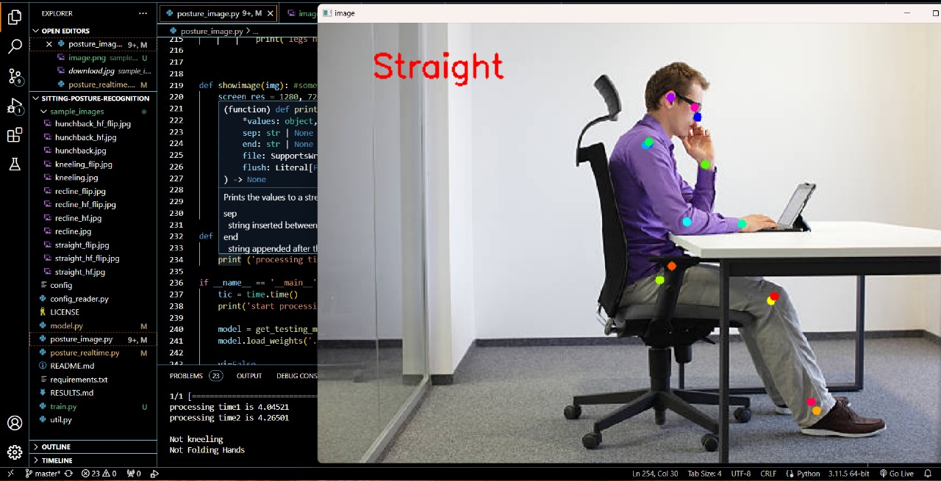
Figure 9. Straight Sitting Posture of single person


Figure 10. Straight sitting posture of multiple people


Figure 11. Rest sitting posture

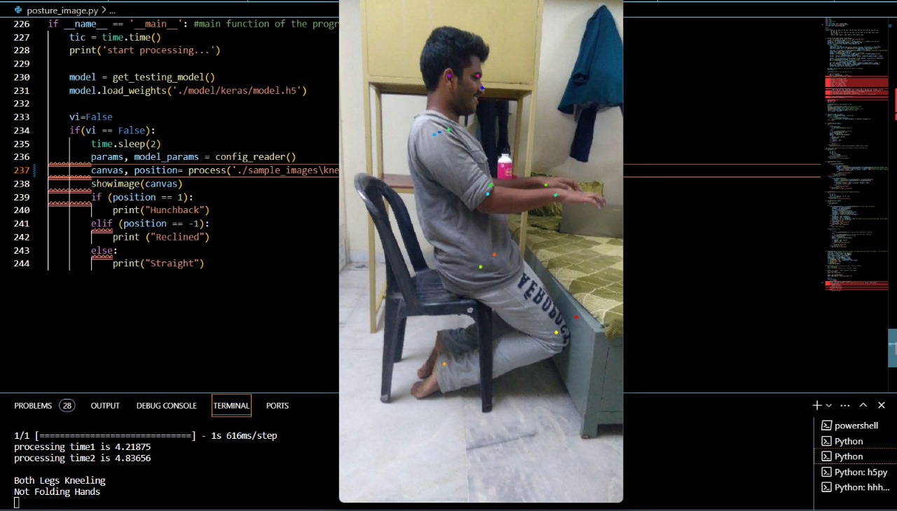
Figure 12. Folding legs posture
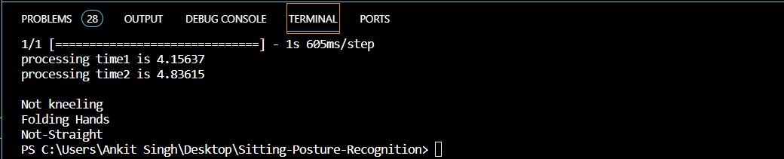
Figure 13. Output Image

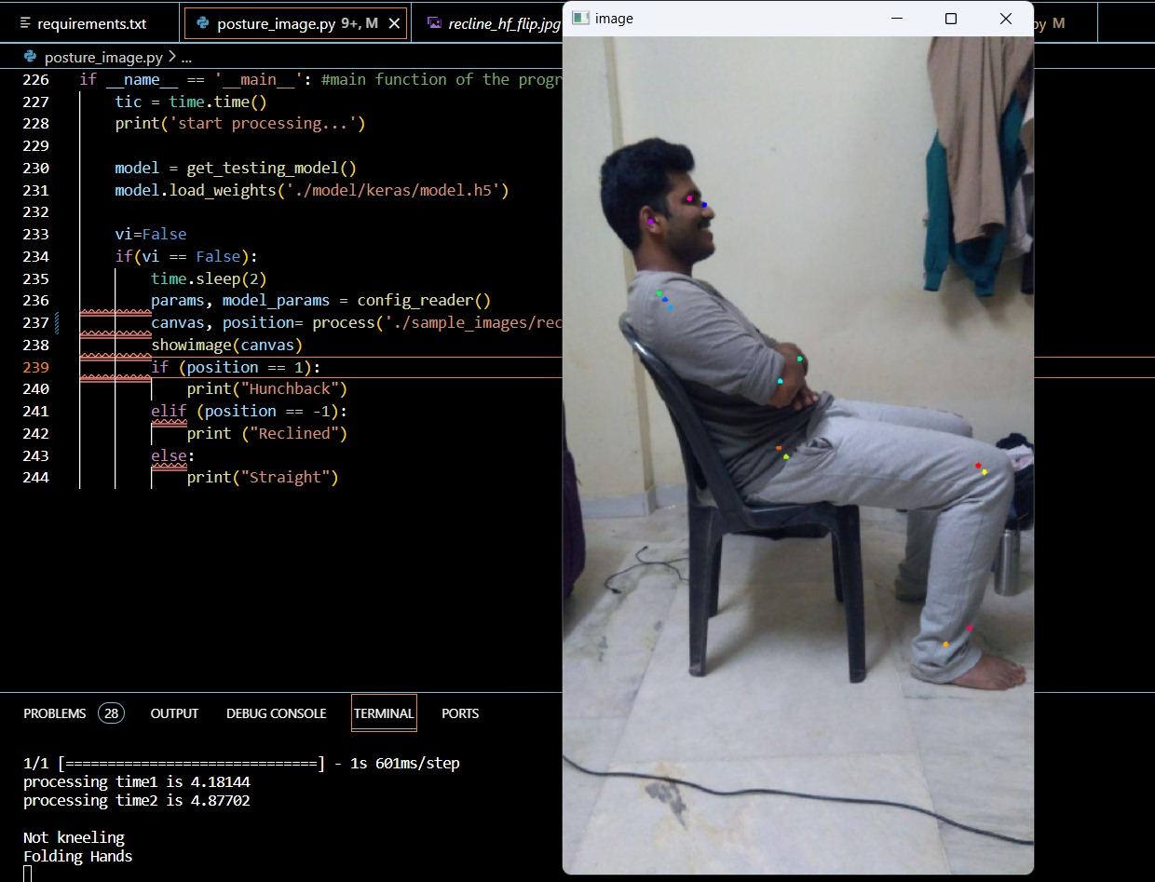
Figure 14. Folding hands and rest sitting posture
CHAPTER- 18

FUTURE ENHANCEMENTS

- Multi-Sensor Integration:

- Explore the integration of additional sensors, such as depth sensors or inertial measurement units (IMUs), to enhance the system's ability to capture a more comprehensive range of posture-related data. This could provide a more holistic understanding of user positions and movements.

- Machine Learning Refinement:

- Continuously refine and expand the machine learning models used for posture detection. Implement advanced algorithms or ensemble models to improve accuracy and adaptability to diverse user behaviors and work environments.

- Dynamic Workstation Profiles:

- Develop a system that automatically adapts to different workstation configurations and user preferences. Implement dynamic profiles that adjust posture recommendations based on the specific ergonomic setup of the telecommuter, ensuring personalized and accurate guidance.

- Integration with Smart Furniture:

- Collaborate with manufacturers of smart office furniture to create an ecosystem where the system communicates with IoT-enabled chairs, desks, or accessories. This integration can provide real-time adjustments to the user's physical environment for optimal posture support.

- Expanded Health Metrics Monitoring:

- Extend the system's capabilities beyond posture monitoring to include the tracking of additional health metrics. This could involve integrating sensors or algorithms to monitor stress levels, eye fatigue, or other factors contributing to overall well-being during remote work.

- Adaptive Augmented Reality (AR) Feedback:

- Implement AR feedback that dynamically adapts based on the user's posture. Augmented reality can provide more immersive and personalized guidance, helping users visualize correct postures and adjustments in real-time.

- Collaborative Virtual Spaces:

- Develop virtual spaces where telecommuters can collaborate and engage in joint activities to promote healthy postures. This could include virtual fitness classes, posture challenges, or shared mindfulness sessions to foster a sense of community among remote workers.

- Voice-Activated Interaction:

- Integrate advanced voice recognition technology for hands-free interaction with the system. Users can receive real-time feedback, make adjustments, and access system features using voice commands, enhancing usability and accessibility.

- Gamification for Engagement:

- Gamify the posture improvement experience by introducing interactive challenges, achievements, or rewards. This approach aims to increase user engagement and motivation in maintaining healthy postures during work hours.

- Cloud-Based Analytics:

- Implement cloud-based analytics to gather and analyze anonymized data from multiple users. This can provide valuable insights into posture trends, user habits, and the overall impact of the system on a broader scale, contributing to continuous improvement.

- Smart Notifications and Reminders:

- Develop an intelligent notification system that provides timely reminders for posture adjustments and breaks. These notifications can be personalized based on user preferences and work patterns, enhancing adherence to recommended postural habits.

- Accessibility Features:

- Enhance the system's accessibility by incorporating features that cater to users with varying physical abilities. This may include voice-guided exercises, haptic feedback, or other mechanisms to ensure inclusivity and usability for a diverse user demographic.

- Privacy-Centric Innovations:

- Explore advanced privacy-centric technologies, such as federated learning or on-device processing, to minimize data transmission and protect user privacy while still achieving effective posture monitoring.

- Cross-Platform Compatibility:

- Ensure compatibility with a wide range of devices and platforms, including different operating systems, ensuring the system's versatility and ease of integration into diverse technological environments.

- User Education and Training Modules:

- Develop interactive modules within the system to educate users on ergonomic best practices and provide training exercises for strengthening core muscles and improving posture. This educational component can contribute to long-term posture improvement.

9.2. CONCLUSION

The culmination of this project, titled "Smart System for Workplace Posture Monitoring," marks a significant stride towards enhancing the well-being of the telecommuting workforce. Through a meticulous exploration of ergonomic challenges and the potential health risks associated with extended computer usage, the project has introduced an innovative solution designed to actively detect and analyze the postures of telecommuting employees. By addressing the pressing need for real-time feedback on posture and advocating for comfortable and proper positioning, the system stands as a proactive measure against musculoskeletal issues and other health concerns prevalent in remote work settings.

The integration of cutting-edge technology, particularly Convolutional Neural Networks (CNNs) embedded in specialized hardware, showcases the commitment to efficient real-time video processing. This not only ensures accurate posture detection, encompassing key elements such as the neck, shoulders, and arms but also goes beyond detection by providing personalized recommendations to telecommuters. The gamification aspect, turning posture correction into an engaging challenge, adds an element of motivation for users to actively participate in maintaining healthy postures.

Emphasizing real-time video processing, the project achieves processing speeds of up to 25 frames per second, enabling continuous posture monitoring throughout telecommuters' work activities. Prioritizing sustainability, the system is designed with minimal power consumption (below 10 watts), making it practical for prolonged use without significantly impacting the user's device or increasing energy consumption.

The accuracy rate exceeding 80% in posture detection underscores the reliability and effectiveness of the system, contributing to long-term posture improvement and overall health. Beyond immediate applications, the project envisions the potential for the system to expand into remote health monitoring, capturing posture-related data and providing a holistic view of the telecommuter's health status.

Ensuring seamless integration into diverse telecommuting environments, the project lays the groundwork for a user-friendly implementation. The potential development of a mobile application or desktop dashboard enhances accessibility, allowing users to conveniently access posture data, recommendations, and progress reports.

Looking ahead, the continuous learning algorithms implemented in the system promise adaptability to changing work environments and habits, ensuring its effectiveness in diverse telecommuting scenarios. The comprehensive privacy measures, including encryption and secure data transmission protocols, address concerns related to user data, maintaining confidentiality throughout posture monitoring.

Incorporating remote monitoring capabilities and a module for the long-term impact assessment, the project acknowledges the dynamic nature of telecommuting and positions itself as a forward-thinking solution within the evolving landscape of occupational health. As workplaces evolve and the significance of employee well-being gains prominence, the "Smart System for Workplace Posture Monitoring" stands as a testament to the commitment to healthier work habits, promoting proactive health management in the realm of telecommuting.

REFERENCES

- Milasi, S.; González-Vázquez, I.; Fernández-Macías, E. Telework in the EU before and after the COVID-19: Where We Were, Where We Head to; Science for Policy Brief; European Commission: Brussels, Belgium, 2020.

- Larrea-Araujo, C.; Ayala-Granja, J.; Vinueza-Cabezas, A.; Acosta-Vargas, P. Ergonomic Risk Factors of Teleworking in Ecuador during the COVID-19 Pandemic: A Cross-Sectional Study. Int. J. Environ. Res. Public Health 2021, 18, 5063.

- Moro, A. Impact of the COVID-19 Confinement Measures on Telework in Italy-A Qualitative Survey; Technical Report; JRC Working Papers Series on Labour; Education and Technology: Econstor, Italy, 2020.

- Nag, P.K. Musculoskeletal disorders: Office menace. In Office Buildings; Springer: Berlin/Heidelberg, Germany, 2019; pp. 105–126.

- Ohlendorf, D.; Sosnov, P.; Keller, J.; Wanke, E.M.; Oremek, G.; Ackermann, H.; Groneberg, D.A. Standard reference values of the upper body posture in healthy middle-aged female adults in Germany. Sci. Rep. 2021, 11, 1–10.

- Openshaw, S.; Taylor, E. Ergonomics and Design a Reference Guide; Allsteel Inc.: Muscatine, IA, USA, 2006.

- Woodson, W.E.; Tillman, B.; Tillman, P. Human Factors Design Handbook: Information and Guidelines for the Design of Systems, Facilities, Equipment, and Products for Human Use; McGraw-Hill: New York, NY, USA, 1992.

- Mallare, J.C.T.; Pineda, D.F.G.; Trinidad, G.M.; Serafica, R.D.; Villanueva, J.B.K.; Cruz, A.R.D.; Vicerra, R.R.P.; Serrano, K.K.D.; Roxas, E.A. Sitting posture assessment using computer vision. In Proceedings of the 2017 IEEE 9th International Conference on Humanoid, Nanotechnology, Information Technology, Communication and Control, Environment and Management (HNICEM), Manila, Philippines, 1–3 December 2017; pp. 1–5.
- Van Niekerk, S.M.; Louw, Q.; Vaughan, C.; Grimmer-Somers, K.; Schreve, K. Photographic measurement of upper-body sitting posture of high school students: A reliability and validity study. BMC Musculoskelet. Disord. 2008, 9, 1–11.

- Khandelwal, I.; Stollenwerk, K.; Krüger, B.; Weber, A. Posture Classification Based on a Spine Shape Monitoring System. In Proceedings of the International Conference on Computational Science and Its Applications, Saint Petersburg, Russia, 1–4 July 2019; pp. 494–509.

- Bibbo, D.; Carli, M.; Conforto, S.; Battisti, F. A sitting posture monitoring instrument to assess different levels of cognitive engagement. Sensors 2019, 19, 455.

- Muppavram, S.; Patel, N.; Nadeem, M. Posture Alert. In Proceedings of the 2018 IEEE Region Ten Symposium (Tensymp), Sydney, NSW, Australia, 4–6 July 2018; pp. 213–218.

- Haller, M.; Richter, C.; Brandl, P.; Gross, S.; Schossleitner, G.; Schrempf, A.; Nii, H.; Sugimoto, M.; Inami, M. Finding the right way for interrupting people improving their sitting posture. In Proceedings of the IFIP Conference on Human-Computer Interaction, Lisbon, Portugal, 5–9 September 2011; pp. 1–17.

- Falla, D.; Jull, G.; Russell, T.; Vicenzino, B.; Hodges, P. Effect of neck exercise on sitting posture in patients with chronic neck pain. Phys. Ther. 2007, 87, 408–417.

- Ma, X.; Niu, Y.; Gu, L.; Wang, Y.; Zhao, Y.; Bailey, J.; Lu, F. Understanding adversarial attacks on deep learning based medical image analysis systems. Pattern Recognit. 2021, 110, 107332.

- Tahura, S.; Samiul, S.H.; Kaiser, M.S.; Mahmud, M. Anomaly Detection in Electroencephalography Signal Using Deep Learning Model. In Proceedings of the International Conference on Trends in Computational and Cognitive Engineering, Dhaka, Bangladesh, 7–18 December 2020; pp. 205–217.

- Li, C.; Zhong, Q.; Xie, D.; Pu, S. Skeleton-based action recognition with convolutional neural networks. In Proceedings of the 2017 IEEE International Conference on Multimedia & Expo Workshops (ICMEW), Kuala Lumpur, Malaysia, 3–6 November 2017; pp. 597–600.

- Nvidia. TRT_Pose Repository. Available online: https://github.com/NVIDIA-AI-IOT/trt_pose.

- Xiao, B.; Wu, H.; Wei, Y. Simple Baselines for Human Pose Estimation and Tracking. In Computer Vision—ECCV 2018; Ferrari, V., Hebert, M., Sminchisescu, C., Weiss, Y., Eds.; Springer: Berlin/Heidelberg, Germany, 2018; pp. 472–487.

- Nvidia. Official Repository of Tool Torch2trt. Available online: https://github.com/NVIDIA-AI-IOT/torch2trt (accessed on 28 May 2021).

- Zhou X, Huang Q, Sun X, Xue X, Wei Y. Towards 3D human pose estimation in the wild: A weakly-supervised approach; Proceedings of the IEEE International Conference on Computer Vision; Venice, Italy. 2017. pp. 398–407.

- Xiao B, Wu H, Wei Y. Simple baselines for human pose estimation and tracking; Proceedings of the European Conference on Computer Vision (ECCV); Munich, Germany. 2018. pp. 466–481.

- Ma N, Wu Z, Cheung YM, Guo Y, Gao Y, et al. A survey of human action recognition and posture prediction. Tsinghua Science and Technology. 2022;27(6):973–1001. doi: 10.26599/TST.2021.9010068.

- Federolf PA. A novel approach to study human posture control: Principal movements obtained from a principal component analysis of kinematic marker data. Journal of Biomechanics. 2016;49(3):364–370. doi: 10.1016/j.jbiomech.2015.12.030.

- Fan Z, Hu X, Chen WM, Zhang DW, Ma X. A deep learning based 2-dimensional hip pressure signals analysis method for sitting posture recognition. Biomedical Signal Processing and Control. 2022;73(2):103432. doi: 10.1016/j.bspc.2021.103432.

- Islam MM, Nooruddin S, Karray F. Multimodal human activity recognition for smart healthcare applications; 2022 IEEE International Conference on Systems, Man, and Cybernetics (SMC); Prague, Czech Republic. 2022. pp. 196–203.

- Siddiqui M. Human pose estimation from a single view point; Computer Vision and Pattern Recognition Workshops (CVPRW), 2010 IEEE Computer Society Conference; San Francisco, CA, USA. 2010. pp. 1–8.

- Liu G, Lin L, Zhou W, Zhang R, Guo H. A posture recognition method applied to smart product service. Procedia CIRP. 2019;83(12):425–428. doi: 10.1016/j.procir.2019.04.145.

- Hernández-Vela A, Bautista MÁ, Perez-Sala X, Ponce-López V, Escalera S, et al. Probability-based dynamic time warping and bag-of-visual-and-depth-words for human gesture recognition in RGB-D. Pattern Recognition Letters. 2014;50(2):112–121. doi: 10.1016/j.patrec.2013.09.009.

- Onishi K, Takiguchi T, Ariki Y. 3D human posture estimation using the HOG features from monocular image; 2008 19th International Conference on Pattern Recognition; Tampa, FL, USA. 2008. pp. 1–4.

PLAGARISM REPORT


